Programme Quality Assessment of AHANA Scheme of Plan India for PPTCT.
National Report
.

(Cover page Perhaps will be designed by Plan India with use of their design section and stock photographs.)

Acknowledgements

(Will be taken care by Plan India)

Preface
National AIDS Control Organization provides HIV counseling and testing services for HIV infection, the critical first step in detecting and linking people with HIV to access treatment cascade and care. It also provides an important opportunity to reinforce HIV prevention. The national programme is offering these services with the goal to identify as many people living with HIV, as early as possible (after acquiring the HIV infection), and linking them appropriately and in a timely manner to prevention, care and treatment services. The introduction of ART services has given boost to Counseling and testing services in India. There are about 21 thousand Integrated Counseling and Testing Centres (ICTC) in India where Prevention of Parents to Child Transmission of HIV/ AIDS services (PPTCT) are also available. It has been estimated that nearly 47 % estimated pregnancies are covered by PPTCT services at all India level.
In an effort to serve the national cause in support of the activities of NACO (in Government of India) Plan India has successfully rolled out Project AHANA to implement PPTCT of HIV in 9 states and 218 districts of India. The project aims to test 1.78 crore pregnant women for HIV and provide access to early infant diagnostics to at least 90% of HIV exposed infants. The project has started in October 2015 and has gained momentum in April/ June 2016 and is now running in full swing and is expected to close its operations by September 2017.

In this context Plan India desired to have an exercise of Programme Quality evaluation conducted by an outside agency in an attempt to learn where does the programme stands today with respect to the quality of services offered by the programme and what best could be done to bring further improvements and had entrusted this assignment to Development Oriented Operations Research & Surveys (DOORS), an NGO and research agency in the social sector.

DOORS have carried out the study in the field with the cooperation of Plan India staff, and the implementing partners of Plan India and prepared this report. DOORS wishes to express its thanks to one and all who had helped in bringing out this report in successful manner.

(T.S. Krishnan)
Acronyms
(To be take care by Plan India+

Contents
(Will be compiled once the chapter writings are finalized)

Executive summary
Parent to child transmission is a major route of HIV infection among children. To stem the tide, the Government of India has committed to providing access to Prevention of Parent to Child Transmission (PPTCT) services to all pregnant women through the National AIDS Control Programme Phase-IV (2012-2017). To achieve this goal, Plan India has been supporting National AIDS Control Programme through its project AHANA (September, 15 to December 2017), supported by The Global Fund. The project aims to increasing PPTCT services uptake in 218 priority districts of 9 states, Assam, Bihar, Chhattisgarh, Jharkhand, Madhya Pradesh, Odisha, Rajasthan, Uttar Pradesh, and West Bengal.

To understand the programme quality and programme delivery towards achieving programme objective, a study was undertaken with the objective of assessing implementation process against quality parameters, performance against target, capacity building and its outcome, IEC/BCC activities, and the data management aspects in the project states.
The assessment has looked into various aspects such as understanding programme implementation process against guideline, performance against the proposed target, sustained outcome of capacity building activities under the programme, sustained outcomes achieved through programme IEC and BCC activities, linkages established with the stakeholder. Programme footprint in terms of removing stigma and discrimination and Programme management systems and understanding at the state level and Data Quality.

Findings were presented in thematic scope of the study:
- Understanding programme implementation process against guideline:
There has been structured guidance provided by the Project Management Unit on the Standard Operating Procedures leading to the well capacitated staff at the state level project management unit of SR. The study findings suggests that mostly, the state level management staff at SR have good understanding of the programme functions and monitoring and reporting arrangement. Some of the SR carried out some meaningful analysis of programme data leading to effective project implementation. Knowledge regarding reporting to SIMS towards enhancing national reporting, the importance of linkages with SACS and NHM official, IEC/BCC activities were found good. Altogether, 32 project staff were interviewed in a group and study finds a stable management system has been established in most of the states to achieve a successful programme delivery. It would be pertinent to notice that constant monitoring and oversight has played a major role in terms of improving the capacity of the SR staff towards a better performance.
The desk review carried out suggests that the project establishes a very strong linkage with the Government systems mostly in all the states. There has been acceptance of the programme by different department of Government and some of the states gone ahead suggesting increased scope for the project for the interest of elimination of PPTCT. Both SACS and NHM officials at the state level were all well aware about AHANA Project and its activities. Importantly, in many of the states it is found that SARC mechanism created by AHANA project as Governance are well functioning. However, in some of states this mechanism has yet to take off as formal arrangement.
Peripheral health workers act as one of the pillar of this project and they are well aware of the basic activities of the project as ORWs are in close liaison with them for all the field activities. The findings suggests in some of the states this coordination is so well established that the district level stakeholders and the peripheral health workers depend on AHANA project structure for the delivery of the standard services and adapted AHANA information management system as their primary documentation source. In West Bengal, district health officials showed that how AHANA registers are helping to keep the primary records of the pregnant women receiving HIV testing at the PHC and sub centre level.
Many of the beneficiaries are not aware of the name AHANA but are well acquainted with ORW and the activities of AHANA. The field operations at the level of ORW, DO and the operations at SR are found to be in accordance with the guidelines under the constant monitoring and supervision by SR staff and Plan officials.
- Performance against the proposed target:
The Project has three core indicators agreed with the donor. Performance analysis indicates that the programme picked up momentum right from the third quarter onwards. The low progress in the first six months was mainly due to the time taken for organisational arrangements including training of staff. The progress reached nearly double in the third quarter as compared to the first semester and then jumped to about 60% in the next quarter and reached 78% in the sixth quarter. In six out of the nine states it has achieved 100 percent pregnant women received HIV testing against the set target during the quarter 6 (Jan-March, 17). In the case of linkage of PPWs with ARTCs, right from the third quarter about 90 % or more of the Positive Pregnant women (PPW) have been covered and in the last two quarters 100 percent of the PPWs have been covered. However in the case of the third indicator there is still gap exists between the numbers of children needs to be linked and those actually received EID. There has been a considerable service facility gap exists in many of the states for providing EID testing services. The study identifies a risk that, unless facility is expanded the programme will continue to suffer in this component.
- Sustained outcome of capacity building activities under the programme:
Three tier capacity building measures helped to a great extent in improving the HIV testing and screening and uptake of the PPTCT services. State Resource Team (SRT) was formed in all the states comprising senior peripheral health workers, at the district level District Resource Team (DRT) was formed by training peripheral health workers on the issues of PPTCT and providing training on the methods of Whole Blood Finger Prick Testing of HIV among pregnant women. The third tier was the volunteers at the block level.
These trainings were provided to the peripheral health workers mainly ANMs to improving demand generations at the periphery level and to increase the capacity for carrying out HIV testing. These trainings capacitated the ANMs to administer WBFPT at the village level, at the camp sites etc. The DRT team is also training other ANMs who have not attended the DRT training and through a cascade approach. This has thus not only improved the capacity of the peripheral health workers in terms of their knowledge and capability but finally increased the access of HIV testing among the pregnant women in the villages.
- Sustained outcomes achieved through programme IEC and BCC activities:
As part of IEC and BCC activities mainly wall paintings and Nukkad Nataks have been carried out. Awareness camps, rallies, and celebration of occasions such as World AIDS day are also conducted. Wall paintings were very successful and many stakeholders commented that it helped raising the awareness among the general population. However, in certain places there are more than one paintings side by side. In some states, there are no wall paintings at HQRS area though they are there in Block office area and in some other states it is vice versa. These activities do get the attention of the general public, the family members of pregnant women and the pregnant women themselves and increases the general awareness. Especially Nukkad Nataks influences even the illiterates when the local dialects are adopted for the Nataks and the message goes straight to their mind. Norms must be prescribed that a second wall painting may not be there within a prescribed distance from the first one and policy for distribution of wall paintings evenly over the geographical area has to be adopted. Paintings could be made more attractive and catchier. Nataks should evenly spread over time and space and conducted at a time and location that ensures crowd.
- Linkages established with the stakeholder:
At the national and state level there has been a very strong linkages and coordination established with the SACS and NHM officials. This was evident from the study findings that not only the state and district level stakeholders have a good knowledge of the programme and its delivery but they actively monitor the project activity and participate in the decision making process. In many of the states the ORW and district officers have very good linkage with the stakeholders, health facilities, ART centres. Very good rapport maintained with peripheral workers, SACS officials, nodal officials in the health department and NHM. Between NHM and SACS their linkage is much better with SACS. Good linkages and coordination led to demand generation and mobilisation of the target population, carry out all the outreach activities efficiently, achieve the targets and also improve reporting to SIMS. Many ORWs and DOs are themselves PLHIVs which enables them to convince pregnant women and their families and effective disease management. Many of the stakeholders commented Nukkad Nataks that discuss the issues openly in easily understandable manner in local dialects, found to be effective in reducing stigma.
- Programme footprint in terms of removing stigma and discrimination:
In many of the districts under the purview of the study, stakeholders were of the opinion that though stigma may still exists, it has reduced considerably through the efforts of AHANA. ORWs and DOs effort towards convincing the PPW for ART treatment and management, educating her family and her neighbors through direct conversation is visible in better and enabled environment. PPWs confirmed that the quality of life has improved, as their position in the family and in the neighborhood has improved considerably.
- Programme management systems and understanding at the state level:
PMU took initiative to mentor and guide the state team and build their capacity to establish a stable implementation unit at the state level. There have been differences in the capacities of these teams and also the management strategies however the study findings suggest that the standard benchmark suggested in the SOP was adhered to. This capacity was trickled down at the district and block level with a state level variation in effectiveness. Target was managed well by the state management unit which they distributed to the district team with guidance. Discussions suggest that the state team maintained a well-defined monitoring and supervision strategy and successfully met the reporting compliance monthly and quarterly. However, during the review it was also identified that some of the state partners could not meet the timeline for report submission, especially Bihar and Chhattisgarh lagged in maintaining the report compliance timeline. Also it has been observed that while state level capacity exists it failed to trickle down at the field level optimally in these two states. Desk review also suggests that the staff turnover has been maximum in these states including both state and district level which also might have adversely impacted to maintain the optimum quality of the implementation.
- Data Quality Review
Reporting and ensuring the quality of data is a critical component of the programme. This is ensured through different built in checks for data validating and data checking in the field. The data quality mechanism established by the PMU are every strong and takes care of the routine data quality parameters. However, still errors have been found in data reporting during the Data Quality Assessment visits by PMU and SR staff. Study identifies mechanism of data validation well in place where data is verified physically by checking the registers and the numbers reported. Once in a month, the DOs are called to the Head Quarters of the SR and the data validation process is carried out with them for their jurisdiction comparing their records and the entries that have been made. Mismatch found with the data reported in SIMS, and mainly because some of the tastings conducted at the periphery other than FICTC and ICTCs are not getting reported by the NHM data reporting mechanism. ORWs are taking special efforts to collect information about these tests and pursue the FICTCs to report the same. SACS and NHM are also pursued to issue suitable instructions in this regard down below to ensure reporting of all screening.

Key recommendations:
- The study identifies a risk that, unless facility is expanded the programme will continue to suffer in this component.
- AHANA guideline is a lengthy document. Some of the important aspects of guide lines can be prepared in bullet form and hung at the offices of the stakeholders.
- The state management units at the SR level needs to be more proactive in monitoring and supervision of the field activities.
- Field level staff should be given a brief task chart about the care and support activities needs to be carried out with the HIV positive pregnant women.
- Trainings should be provided in regional languages to increase effectiveness. There should also be a manual translated in vernacular languages.
- It has been generally felt that there should be periodical refresher training for the programme staffs.
- There should be mechanism to induct newly recruited peripheral health workers under DRT curriculum.
- The ASHAs and the Anganwadi workers can also be roped in for training.
- Paintings could be made more attractive and catchier. Nataks could be evenly spread over time and space.
- As a part of IEC /BCC activities pamphlets, bit notices can be printed and distributed.
- Hoardings can be erected at important places where people normally used to crowd. Visual aids may adopted for these activities as they may have a better effect.
- There should be norms prescribed for wall paintings so that they are posted in the right locations and also walls not painted side by side.
- Periodical meetings of all stakeholders at different level could be held for dissemination of up to date information, exchange of ideas and charting our further strategies for still better achievement.
- Governance mechanism including SARC and DAC meetings needs strengthening as few of the states lagging behind in implementing these events.
- Periodical bulletin can be prepared and circulated to all stakeholders, to increase the visibility and also the ownership.
- The data reporting could be more dynamic or real time basis with the help of the dedicated network for the purpose from the point of origin of the data as and when an event occurs. To avoid the chances of duplication linkages of ADHAAR CARD could be explored.

Programme Quality Assessment
1. Introduction

1.1 Plan India, a member of Plan International Federation, is a nationally registered independent organization committed to creating a lasting impact in the lives of the vulnerable and excluded. Among other things, Plan India its partners are engaged in improving the health care. In the field of health care Plan India is carrying out a national programme, Project “AHANA” (meaning ‘first rays of the sun’ working towards an AIDS-free generation in partnership with the National AIDS Control Organisation (NACO) and supported by the Global Fund to Fight AIDS, Tuberculosis and Malaria (GFATM). Parent to child transmission is a major route of HIV infection among children. To turn the tide, the Government of India has committed to providing access to Prevention of Parent to Child Transmission (PPTCT) services to all pregnant women through the National AIDS Control Programme Phase-IV (2012-2017).
Project AHANA focuses on increasing PPTCT service uptake among women in most marginalised communities in India. AHANA is being implemented in nine states- Assam, Bihar, Chhattisgarh, Jharkhand, Madhya Pradesh, Odisha, Rajasthan, Uttar Pradesh and West Bengal.

1.2 Plan India remained committed to maintain the quality of the project throughout the project life cycle. There is a Standard Operating Procedures in place developed under project and has been particular about partners following the systems and checks that may act as Quality Assurance Standards, for the implementation of the Project. The standards comprise of minimum acceptable requirements and in fact they can be referred to as benchmarks. Service providers are trained to deliver services as per standards and the standards are used to assess the work and its quality as part of monitoring activities and Programme Quality Monitoring becomes part of these exercises. Programme monitoring intends to check how far various standards set through the guidelines for the programme are understood and followed and identify the gaps if any and locate the corrective actions. Plan India also maintain different processes for grant oversight such as Grant Monitoring Visit (GMV), On Site Data Verification visit (OSDV) etc. As the Project has completed more than three fourth of its period, a study was initiated to understand the quality of the project implementation. A research agency “Development Oriented Operations Research & Surveys” (DOORS) was selected to carry out this activity.

2. Objectives
The main Objectives of the Programme Quality Assessment are to
- Review and assess the programme implementation process against the quality parameters of Programme guideline.
- Review and assess the performance of the programme against set target.
- Review and assess the different components of training programme, methods, and the achieved outcomes against the set target.
- Review and assess the different components of IEC and BCC activities against the set objectives.
- Review and assess the data management and reporting systems maintained at the state level.

3. Methodology
It has been a qualitative study primary based on in-depth interviews at various levels of stakeholders. The study involved the stakeholders at state level and district level, peripheral health workers, and the primary beneficiaries (HIV Positive pregnant women) as the study respondents for the open ended in depth interview. Desk research has been carried out for the performance analysis at the state level and observation method has been applied for the data quality and maintenance at the SR level. A group discussion technique has been adopted to understand the knowledge about the programme with SR staffs at the state level.

4. Sample selection

4.1 The assessment has been carried out in each of the nine states at State level, Sub Recipient level, district level and below. For the purpose of the work at district level a sample of districts within each of the nine states has been selected.

4.2 A multi stage stratified cluster sampling has been adopted. All the districts in a state where AHANA is implemented were classified into two strata (groups) based upon their performance and selected equal number of districts from each stratum to give equal representation for good performing and bad performing districts. In some of the states the districts originally selected had to be substituted due to various administrative issues. The details of districts covered for the survey in each of the states are given in Table 4.1
Table 4.1 The details of the districts covered for the study.
Sl. No. | State | District covered
1 | Assam | Karbi along and Darrang.
2 | Bihar | Khagaria, SAMASTIPUR, Supaul and Darbhanga
3 | Chhattisgarh | Dhanbad, and Deogarh
4 | Jharkhand | Raipur and Mahasamund
5 | Madhya Pradesh | Gwalior, Morena, Ujjain and Dewas
6 | Odisha | Cuttack and Jaipur
7 | Rajasthan | Churu and Jhunjhunun
8 | Uttar Pradesh | Aligarh, Hathras, Lakhimpur kheri, Hardoi, Faizabad, Gonda. Gorakhpur and Maharajganj
9 | West Bengal | Kolkata and Bankura

The in-depth interviews were conducted contacting NHM, SACS at state level, two officials at district level from Health facilities / NHM / SACS, two peripheral workers - ANM/ASHA and two HIV Positive Pregnant Women who are the beneficiaries from district and below levels. In addition detailed discussions were held with the officials at SR level at their office and their records were observed. The number of interviews envisaged and actually conducted are indicated in Table 4.2
Table 4.2 Number of interviews planned and achieved.
Stake holder | Number of interviews
Stake holder | envisaged | conducted
State level officials | 18 | 16
District level officials | 56 | 56
Peripheral workers | 56 | 58
Beneficiaries | 56 | 51
Total | 186 | 181
5. Observations.
  - Understanding programme and implementation according to guidelines.

    - There is a fair level of knowledge at the state level implementation teams. In some of the states there are initiatives “beyond call of duty” also which is worth noting. In some of the states it is found that the Project coordinator has joined only recently so yet to get the complete grip over the issues. In some places M&E officers are more aware and somewhere the Project coordinator is more aware about the project guideline and standards. But as a team they know fairly well about the different aspects of the programme. Particularly, SR teams and the staff are very well aware of the different indicators, their definitions and how they are calculated and what are the denominators for the three core indicators.
    - SARC and DAC have not been constituted in all the states. Apart from MP, Jharkhand and ASSAM all other states have formed SARC and carried out the meeting. While in Assam the first meeting is scheduled next month, in MP a conscious decision has been taken by the Project Director SACS that there is no need to form a separate SARC or DPC. An SR official informed “we have been advised by MD (mission director) of NHM for not forming a separate committee and utilising the existing structure. At district level, district health society meeting (DHSM) is conducted by collector. CMHOs, deputy CMHOs, RCHOs, and all other staff at block level are called at the collectorate to discuss the update of programs implemented through NHM. We indicate our program agenda too at the DHS and it is reviewed by the collector. We get the minutes of this meeting.” In Madhya Pradesh no separate SARC has been constituted.

SARC at Madhya Pradesh Mission Director NHM and Project Director SACS decided in a meeting SACS officials and NHM personnel that NO need to have a separate SARC constituted. State oversight committee can review of PPTCT -AHANA

All the ORWs have given a short list of outreach activities for PPWs and also the other activities and confirmed that they are being carried out by the ORWs. ORWs go beyond what has been prescribed for them and help the PWs and PPWs and the children born to them in all possible manner. There had been several occasions where ORWs have taken extra steps to help the PPWs. | Task sheet for PPWs  Identify and list PPWs  Prepare Test Cards  Obtain consent.  Visit ICTC and ART centre periodically  Collect particulars of PPWs directly registered at ICTC or ARTC & follow up visits of PPWs to ARTC  Prepared CETC for PPWs directly registered with ICTC/ARTC  Collect photocopies of supportive documents for CETC with consent of PPW  Orient PPW on importance of TB diagnosis and treatment  Ensure confidentiality of all information pertaining to PPWs  Make home visits to each PPW at least once in a month  Update all the information periodically

“Beyond Call of Duty” (Ujjain District, Madhya Pradesh)
As the labour pain felt, Sabita Rani (name changed) a HIV positive pregnant women visited the nearest health facility for delivery. She was admitted there for 24 hours and referred to Block level hospital as the labour pain did not increase. She went there and was admitted and kept for the whole day with no action, and in the night she was referred to District Hospital without stating any reason. Sabita was transported through a district hospital van and the driver charged her Rs. 250. The doctor on duty at District Hospital refused to admit her and referred her to the Speciality hospital in the neighbouring district on the plea of low CD4 count informing Sabita and her husband that there is danger of acquiring infection. At this stage ORW Jyothi intervened and tried to meet CMO but failed to reach him. Then on emergency note the case was taken to district Civil Surgeon who then intervened and finally, Sabita delivered a healthy baby in the District hospital itself. With ORW_Jyothi’s intervention she also got Rs. 250/- back and the driver was suspended from service.

Walking that Extra mile for a smile (District Morigaon, ASSAM)
Sulekha Begum (name changed) was so poor that she could not afford two square meal a day. She was referred to the Medical hospital from periphery for delivery. She got admitted in the Medical college hospital with the help of ORW. As the hospital did not have “Safe Delivery Kit”, the doctor asked Sulekha to purchase the same. She did not have money for even food and/or transport, and remained clueless. ORW Ms. Rekha Devi in discussion with SR discussed the issue with SACS at state level. SACS finally asked SR to purchase, assuring that the expenditure will be reimbursed by SACS. The kit was purchased immediately and delivery was carried out. However, the expenditure is yet to be reimbursed, but AHANA managed to ensure a ‘SMILE’ because the ORWs always walk an extra mile.
5.1.3 Next to ORWs it is the peripheral workers who play an important role in making the AHANA programme a success. More than 50 percent of the peripheral workers were well aware of the AHANA programme and another 30 percent know fairly well. The different levels of awareness among the peripheral workers is given in Chart 5.1. | Chart 5.1 Awareness of AHANA programme in the case of peripheral workers
Although NHM officials at state and district level are well aware of the project activities but the ownership found more with the SACS officials.

5.2. Performance against the proposed target.

5.2.1 The project had a very ambitious target set with the donor, to increase the HIV testing among pregnant women from 18% at the baseline to 85% within 18 months’ time. The target for various indicators have been fixed on quarterly basis and achievements against each target has been maintained. In the 218 districts covered by AHANA put together the target has increased from 24% in the first six months of the project (Oct 15 to March 16) to 78% in the 6th quarter ending March 2017. The achievement had been hovering around 50-60 % for quite some time and had a quantum jump to 78% in the last quarter. The details of the progress are given in chart 5.2. Other than UP, Bihar and Rajasthan the rest of the AHANA states have recorded more than 100% achievement.
Chart 5.2 Screening for HIV of Pregnant women

It is only UP which had got stuck up at around 50% being the lowest achievement for any State. However the percentage of pregnant women got screened for HIV against the total number of women registered for ANC stood at 56% in the last quarter. It could be considered to measure the progress against the ANC registration only.

5.2.2 Right from the third quarter the progress with regard to linking of PPWs with ART centres has been good. It was about 90% in the beginning and has achieved 100 percent in the last two quarters. It is only in Chhattisgarh and Rajasthan that had recorded less than 100% achievement, Chhattisgarh being the lowest (75%). The details of achievement over the period are indicated in Chart 5.3

hart 5.3 Linking of HIV+ve Pregnant Women to ART

5.2.3 However in the case of EID for children born alive for PPWs there exists a gap. The percentage of children(<2 Months) born to HIV+ve women received EID against the target remained at about 25% in the first three quarters and around 55% in in the last three quarters. The details of performance are given in chart 6.4. The low percentages have been marked in Assam, Bihar and UP. The main reason for the gap is the dearth of enough testing centres for EID. The states could see that the testing centres for EID are established at least in all district of the state.
Chart 5.4: Testing for HIV of Children (2 months) born to HIV+ve Women

5.2.4 Achievement in a state mainly depends on the enthusiasm and efforts put by ORW, the infrastructure available and the interest evinced by the officials in the health system. In the 218 districts Where AHANA is operating there are 66109 health facilities, 1875 FICTCs and 943 ICTCs. There is only about 4 ICTCs on an average for each District. But the testing facilities are not uniformly distributed over the states. However this indicates the need to increase the number of testing facilities.
Good and Not so good examples of interest of Health system officials
It has been seen that there is a direct correlation between performance and the effort and agility of ORW, the infrastructure and the interest taken by the officials in the health system. Two senior doctors ,one in a Sadar Hospital and one in a PHC both being at the verge of retirement are seen coming to the office before 7.00 am and going to the field to make arrangements for camps and taking extra interest in making arrangements for testing.
On the other hand examples are there, senior officers in the health department depending on lower level staffs for the job getting done without giving any proper direction and not taking accountability of the cause.

5.3 Sustained outcome of capacity building activities under the programme.

5.3.1 Under the capacity building component, staff of AHANA and other stakeholders and specifically peripheral health workers have been trained. This is a key component as under AHANA through District Resource Team curriculum ANM and Sr. ASHA workers have been trained. This is very important in terms of generating capacity across the peripheral health worker, which will then lead to increase in HIV testing among pregnant women. Only a small fraction of the Peripheral workers have been trained in all the 128 districts put together. The details of training of ANMs and ASHAS are given in Charts 5.5 and 5.6
Chart5.5 Position of Training of ANMs Chart5.6 Position of Training of ASHAS

5.3.2 The training has increased the knowledge of the ANMs. They were not knowing anything about testing earlier. Now they know how to carry out WBFPT and this has helped in their carrying out the screening at the VHND and at various camps which in turn has helped in the increase of number of pregnant women screened for HIV. Nearly three fourth of the Peripheral workers contacted have been benefited a lot. The levels of benefit of training to the peripheral workers are given in chart 5.7

Chart .5.7 Benefit of the training to the Peripheral workers

5.3.3 The training has improved the capability of the health workers and in turn has increased the screening of the PWs considerably. A Consultant, Maternal Health, NHM, has said
“Testing were done earlier too. But AHANA programme and its trainings have given due emphasis on the correct way of testing and importance of reporting and consequently things have improved as we could see the result in the 17 districts”.

5.3.4 There had been trainings to health staff (DRT, SRT, Volunteers) Training on SIMS to DEOs, training on new MIS to DOs and ORWs. It had substantial impact on tracking and screening pregnant women, follow up activities of PPWs and their children, maintaining quality of data and reporting including reporting to SIMS.

On the effect of training
“Screening went up from by about 30 percent due to training” – Dr. AshaSaini,_DPM, NHM, Rajasthan
“Motivation has increased due to training” - Dr. Asha Saini, DPM, NHM, Rajasthan
“The testing has extended from district level to lower levels due to training” – Dr Vikram Singh, DPM, NHM Rajasthan
I learned how to use the kit in the training – Smt. Jamwati, ASHA supervisor, Jhunjhunun, Rajasthan

5.3.5 Chhattisgarh and Jharkhand have excelled in the field of imparting training with more than 75% of their ANMs having been trained besides considerable number of ASHAs also having been trained. The only other state which has trained neatly half of the ANMs is Bihar (49%). This may be the reason for their consistent higher performance in the field of screening the PWs as compared to all other states positively indicating the effect of training. Whereas none of the ANMs and ASHAs have been trained in Madhya Pradesh and West Bengal. In Odisha none of the ANMs has been trained and in Assam none of the ASHAs have been trained. Assam and Rajasthan have trained only one to 2 percent of their ANMs

5.4 Sustained outcomes achieved through programme IEC and BCC activities

5.4.1 As part of IEC and BCC activities, wall paintings, Nukkad Nataks, Rallies and other activities such as awareness camps, celebration of important events such as World AIDS Day have been taken. Wall Painting is one of the important activities for creating mass awareness on HIV/AIDS and PPTCT related messages to communicate at large level to create long term impact. It has been seen in Madhya Pradesh in some of the districts there is no wall paintings at district Headquarters and in some of the districts there is no wall painting in places other than the district headquarters. Bihar is the only state which has put up wall paintings in more than 1000 PHCs already by March 2017 and have called for quotation in June 2017 for wall paintings in 22 districts. Assam is the only state which has not reported any wall painting and UPNP PLUS is the only SR with less than 100 wall paintings. In all the 128 AHANA districts there are 3902 wall paintings which accounts to only about 30 painting on an average per district. Wall paintings have attracted the attention of the local population and increased awareness among them. West Bengal and Odisha are leading in the average number of wall paintings per district with 46 and 42 numbers respectively. They are followed by Bihar with 33. Chhattisgarh, Jharkhand and Rajasthan have 22-24 wall paintings on an average per district, Madhya Pradesh and Uttar Pradesh are the only two states with less than 10 wall paintings per district each. Within Uttar Pradesh UPNPplus has put up only about 2 wall paintings per district on an average. Assam has not reported any wall paintings.

5.4.2 In Khagaria District in Bihar, wall paintings are crowded within a small area. Two paintings of exactly the same matters and design are there side by side on the same wall. It seems as though it has been done to fulfill some quota rather than for serving some useful purpose. It must be ensured that the paintings are well distributed over space.

5.4.3 In all 4307 Nukkad Nataks have been carried out. Madhya Pradesh is the only state which has carried out more than 1000 Nataks and West Bengal is the state which has conducted less than 100 Nataks. Nukkad Nataks have a better effect as compared to wall paintings and covers various issues unlike wall paintings. Madhya Pradesh has performed nearly 30 Nukkad Nataks per districts. In all other states except West Bengal the average was ranging from 14 to 20, West Bengal’s average was just about 4.

5.4.4 In Bihar both SACS and NHM officials and in Madhya Pradesh NHM official have not seen the wall paintings or Nukkad Nataks. In Jaipur, Darbhanga, Darrang Ujjain and Gonda districts, the district level officers and in Ujjain, Darrang, Morena, Jaipur, Bankura and Gonda the peripheral workers have not seen the wall paintings. This leads to the conclusion that considerable size of the population would be unaware of these IEC / BCC activities of AHANA and there is need to upscale these activities to considerable extent.

5.4.5 Street Plays were essentially organized for generating awareness of HIV and it is felt that such events should be organized on regular basis as they have helped in creating awareness even among illiterate people.

5.4.6 Shri Omprakash, BPM, Churu said “As the Nukkad Natak that he attended was during day time, the gathering was less. He felt that these activities should be done on a regular basis and at a suitable time when they could attract larger crowd. In his own words “In rural areas slogans create effect”.

5.4.7 Through the street plays people have come to know about HIV, its cure, and the fact that it is not a social stigma, ANC, TB etc. It also told to the people how the disease can be stopped from transmitting to the child from the mother. It had helped in reducing stigma to great extent.

5.4.8 Many of the peripheral health workers felt that BCC activities are very effective in creating awareness.

5.4.9 SACS in Rajasthan has certified that all the design for all activities and wall paintings are done only after the approval of their department. In some of the states folk troops empaneled with SACS were involved with slogan preparation.

5.4.10 Besides wall paintings and Nukkad Nataks, there had been 128 rallies till March 2017 and there had not been even a single rally in the state of Assam and in the case of SR-UPNP Plus. There had also been 245 other events out of which 104 were carried out by a single SR –MAMTA. Spreading these activities proportionately over the SRs could be ensured. Jharkhand, Odisha and Rajasthan have conducted as many rallies as the number of districts covered whereas others have not. West Bengal is the only state which has reported a number of other events under BCC. In all states except West Bengal 15 to 20 hundred people per district have participated in the BCC activities whereas in West Bengal only 1200 have done so. Thus the activities are limited to a small section of the total target population.

5.4.11 Audio visuals on some comprehensive subjects could be screened as it will attract the attention of people on larger scale. Pamphlets and notices can be printed and distributed and hoardings could be erected to create more awareness.

On quality of Wall Paintings
Shri Charan Singh, DPM, Churu has observed “I saw a poster. HIV is really a sensitive issue. The layman should understand it. The pictorial representation and language are so clear that normal person will also be able to understand it. Though my input is not there I feel the work is OK”.

On BCC activities
Dr Anurodh Tiwari, consultant, Maternal Health, NHM, Jaipur said, “I have seen the BCC activities during my visit to a PHC. Besides I have received updates from DOs. Nukkad Nataks and other activities via photographs. These activities generate self-motivation among people to understand that HIV testing is equally important as other regular tests are. These activities require boost up. We know details about what is going on in the field in this regard. AHANA team coordinates with us and inform us what they are going to do. When they designed the activities they showed it to us and we and SACS checked the same.

The Turning Point….. A Case in Odisha
Husband aged 26 of one of the diseased PPWs holding his 6 months old baby girl in his arm, came to meet the researcher on 4th July 2017 during quality assessment study of AHANA programme. He has lost his young wife (22 years) diagnosed HIV Positive soon after her first delivery. Now he is the sole care taker of the small baby. The baby is receiving all required immunisation and the test confirms that baby is negative.
After the demise of his wife, he was not able to say any word to his relatives and in-laws for the cause of death. The news spread that she died due to severe Jaundice. He sensed that if the real cause of death is known to the villagers, he may not be allowed to stay in the village. Now he is speechless on the subject. He was so much disturbed due to her demise and not being able to express anything in front of others.
He was crying and narrated the entire sequence of events. He was not much aware of the name AHANA, but told that the ORW was visiting routinely to his wife during pregnancy. He is aware on ART and other social schemes related to the safety and security of pregnant women.
He is good in singing and recites Paallah (a local folk song in Odisha, sung in a story form). After the demise of his wife he has dedicated himself to sing Paallah to educate other people on HIV positive infection and its prevention through his singings and spreading health messages. He also got himself involved with AHANA team and voluntarily sing in the community mobilisation events organised by AHANA team.

5.5 Linkages established with the stakeholder:

5.5.1 ORW has established perfect liaison with base level health system staff such as Anganwadi worked, ASHAs and ANMs who are in close touch in village population which enable them to have easy reach to the villages in general and PWs in particular and establish good rapport with them that had resulted in the success of screening of PWs linking PPWs with ARTCs, ensuring care of the new borns in the case of PPWs and reducing stigma They have also established good linkage with the officials of the health system, NHM and SACS both at state level and at District level that enable them to get the necessary directions issued from higher ups to the lower formation and get proper advice and guidance for smoothly carrying out the program and solve various issues related to supply of kits, reporting to SIMS, conducting of IEC/BCC activities etc and ensuing better functioning in thee regard.

5.5.2 At the state level the SR team as well as Plan India representative in the state maintain absolute liaison with SACS and NHM though in comparison the relationship with SACS is stronger and closer than that with NHM. Here again AHANA team keeps the state level official informed of all the facts and figures and take feedback, get decisions on policy matters quickly, get directions issued from the state level to down below on all operational aspects.

5.5.3 There had been very good and close coordination throughout the programme with both SACS and NHM only in Rajasthan and West Bengal. It is only in the case of Rajasthan and West Bengal that both SACS and NHM have told that there is very good and close coordination. In Madhya Pradesh NHM had said that there is coordination but not very regular, but the SACS has said that there is no cooperation at all. The statement of SACS is contrary to many other observations by them and could not be taken at its phase value. In all other States There is very good cooperation observed between AHANA and NHM and a regular coordination between AHANA and SACS. AHANA has excellent linkage with more than half of the state level official, about two third of the district level officials and about three fourth of the peripheral health staff. They also had a good linkage with the rest of the stake holders. A complete picture on the extent on linkages with different stakeholders can be seen in chart 5.8
Chart 5.8 Extent of linkages of AHANA team with various stakeholders

5.5.4 Dr Anurodh Tiwari, consultant, Maternal Health, NHM Jaipur has noted that AHANA’s linkage is multidimensional. The most important link is between coordination with RSACS and NHM and that is coming on the right track. State Representative of Plan India and the SR team keeps connected directly through various communication channels like Phone, Text and other applications. The senior official is also connected with DOs via field staff for all information exchange.

5.5.5 Ms. Asha Saini, DPM, NHM, Jhunjhunun felt that it is the combination of Government policy related to the programme as well as trainings from AHANA and the efforts put by AHANA team that has resulted in improvements and this indicates the success of good linkage.

5.5.6 Shri Charan Singh, DPM, Churu has observed that AHANA staff come every 15 to 20 days, share their information, take the feedback and coordinate on a regular basis for the implementation of the programme.

SR on linkage
“Challenges are plenty and we deal with them on a daily basis. We are able to come up with some solution or the other either at the block level or the district level and if required, we take support from state officials. They give letters and orders to the CMHOs and district level NHM staff so that our work at the field get easier in terms of implementation of the project.” - Sub Recipient, Rajasthan

SACS on Linkages
“At Grass root level i.e. sub centre level where ANC registration are being done ORW and DO help to mobilize pregnant women for checkup and screening and to take the person reactive to the testing centres for confirmation. With group coordination and efforts of RSAC, NHM, AHANA, MNJY and district level health departments, the progress has increased. We hope to increase the same further.”. -Shri Satveer Lamba, AD-BDM, RSACS, Jaipur.

5.5.7 Besides the linkage with partners in the cause, at certain places an excellent linkage with media was also observed due to which any activity related to PPTCT is getting flashed in the media attracting the attention of the public and in turn creating more interest among the public to serve for the cause and to take benefit of the programmes related to the cause.

A news clip from the daily “Prabhat Kabar” dated 9th July 2017 at Supaul that indicates the level of liaison with media.
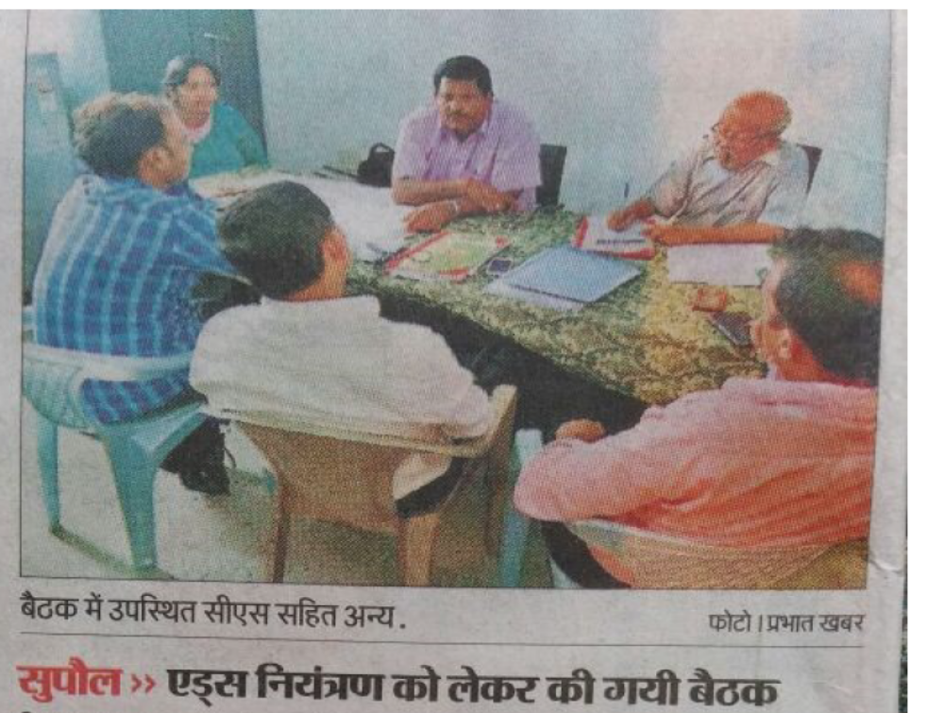
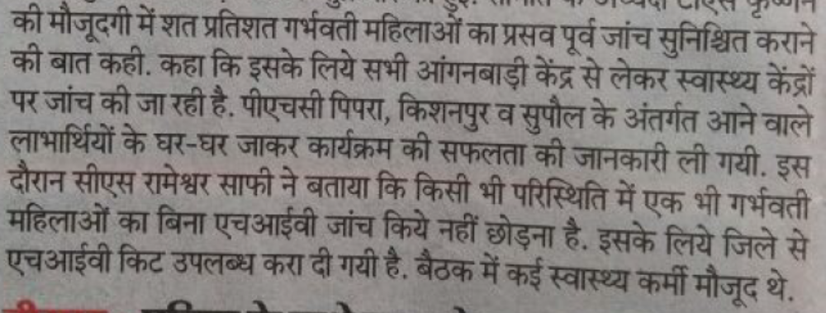

5.6 Programme footprint in terms of removing stigma and discrimination.

5.6.1 Stigma around the HIV existed in the field and thus AHANA had been attempting all along to reduce this stigma through its different methods e.g. Nukkad Nataks, community meeting, through repeated personal visits and counselling the PPW, the family members and the neighbours, through meetings in the PLHIV network; through community sensitisation; through canvassing and getting conduct of HIV test for the spouse, Preaching and promoting Universal HIV screening etc.

5.6.2 According AD, ICTC, ASACS, Assam, stigma has been reduced due to creation of better awareness among the local people by AHANA team by various methods. AHANA workers with their good linkage with ASHA and Anganwadi workers have contributed in reducing the Stigma by all the methods especially creating awareness in the community and counselling all concerned.

5.6.3 Almost all the officials at state and District level contacted have agreed that stigma has been considerably reduced due to the efforts of AHANA in creating awareness among larger population through various activities. IEC/ BCC activities have contributed to reduction in stigma. In Assam the reduction due to this aspect was estimated by the officials to be at the level of 10 to 15 percent.

5.6.4 In Rajasthan, it has been told that people are not ready to accept the positive person in family or in society and the fear factor is high and to save the beneficiary from social negligence or discrimination so many precautions are being taken to communicate to any beneficiary. There seems to be some rules and regulations related to when and how to contact any beneficiary in order to protect the interest of the beneficiary. A permission from SACS seems to be needed for meeting any beneficiary at any time. SACS Rajasthan alone has felt more efforts have to be put in the direction of reducing stigma even though, the awareness created among the people has resulted in some reduction of stigma and discrimination.
5.6.5 The ORWs are mostly local people, in some of the states ORWs and / or DOs themselves belong to PLHIV group. Hence it is easier for them to convince others and reduce the stigma by self-example and by proper coordination and various activities.
5.6.6 Almost all the PPWs contacted during the study are not facing any difficulty either in their family or in their surroundings with neighbours. Some of them have narrated their history

Stigma- A story of a PPW.
My family members started behaving differently. I became very sad and did not want to live any more. But Bhaiya was always on my side. Bhaiya used to console me and give me encouragement and courage. He explained to me that I need not worry at all and everything will become normal. He said he is there and he will help me to come out of the situation and to lead a normal life. He also spoke to my family members and explained to them nicely that they need not worry about the disease and it will not spread to any one and they can touch me and move with me and they should give me courage and encouragement. My child was born in the hospital and is free from disease (Negative). Now my family members are also not dealing with me differently. They take care of me and my child. I am very happy

Stigma – Change in the situation

When I was tested positive society did not care for us and most of the society neglected us. Neighbours were hesitant at first to talk and interact with me and my family members. Now, situation has changed and neighbours stared talking with me and my family in the same way they used to do before my test. My mother supported me most when she first heard about my status. I cannot forget the role of the Outreach worker and AHANA staff for giving me a positive outlook and also overcoming the stigma.

What the PPWs say
I have full support from family
People started ignoring and in-laws left. But parents are supporting
Only few in family know about HIV status. Brother supports me and my family -
Everyone supports me. I don’t face any problem or issues
I don’t face any problem. My family supports me
There were difficulties at the start. With the visits of DO and ORW often the situation has changed to a great extent .I do not feel any difficulty now

5.6.7 AHANA has already put the PLHIV in service delivery in some of the States and is engaging the community with the assistance of ANM, ASHA and Anganwadi workers, carrying out counselling, working with PLHIV network, training the health workers, disseminating information on infection related issues though Nukkad Nataks and these activities have reduced the stigma to some extent. The effect is limited due to some of the activities like Nukkad Natak that play a vital role being carried out on lower scale. Such activities have to be conducted on higher scale.

  - Programme management systems and understanding at the state level

5.7.1 The programme is managed in partnership with NGOs (SRs) in the states. SRs – the implementing managers in the field are aware of these aspects and are translating them into action in the field.
Setting up of target
A Project Co-ordinator of an SR said “Number of women to be tested in the state was decided by Plan India. This was state level target, from that we made district level target and then block level target so that each outreach worker gets his target as set by Plan India.”

5.7.2 SMU at Headquarters and DOs and ORWs in the field together manage the programme, the former giving direction and guidance and administering through various steps such as capacity building and; monitoring the programme and the latter carrying out the activities in the field. Both the SR and those in the field know well their roles and the requirements of the programme well. Capacity building through various training programmes conducted with the cooperation of state health system, NHM and SACS, Mobilisation meetings, with different groups at village level that create awareness among the various sections of the population, advocacy meetings and DAC meetings with district and state officials that help smooth functioning of the programme in the field, organising IEC and BCC activities, and the most important aspect ,the outreach activities carried out by ORWs form the various steps of management. Ensuring proper linkages with different stakeholder, Looking into the various governance aspect along with health system, NHM and SACS, ensuring the infrastructure facilities and availability of consumable, like the availbliay of kit items also form an integral part of the management.
5.7.3 Except in the case of Bihar Jharkhand and West Bengal in all the other 6 states there was very good understanding of Goals and objectives and strategy of AHANA scheme. Three states also had a good understanding. Assam, Madhya Pradesh, Rajasthan and West Bengal have a very good knowledge about indicators and their denominators. The performance of the states against the three indicators as in the 6th quarter (Jan to March 2017) may be seen in chart 5.9
Chart 5.9 Performance of Stages against targets for the three indicators.

Looking into the details of the PPTCT activities from the quality point of view, the performance was more than satisfactory in Assam, Chhattisgarh, Jharkhand Odisha and UP-UPNP+ and satisfactory in the rest of the places.
5.7.4 The level of awareness about AHANA and its programme among the other stakeholders in indicated in chart 5.10

Chart 5.10 Level of Awareness among district officials and peripheral health workers

The knowledge of the various meetings, their definition, composition is more than satisfactory in 50 percent of the SRs (Assam, Madhya Pradesh, Odisha, Rajasthan and West Bengal) and in the other 50 percent it is just satisfactory. No of different type of meetings held and number of persons attended such meetings as at the end of March 2017 are given in chart 5.11 and 5.12 SR wise.
Chart 5.11 Number of different types of meetings held

Chart 5.12 Number of persons attended various types of meetings

5.7.5 About 57 percent of the district officials felt that the advocacy meetings are very much useful and the other 43 percent had felt that the same are somewhat useful.
5.7.6 SARC has not yet been constituted in Assam, Jharkhand and Madhya Pradesh. In Assam and Jharkhand it is in the process of formation where as in Madhya Pradesh SACS has taken a decision not to form the committee. The performance of SRs on various accounts are given below in table 5.1

Table 5.1 Performance of SR on various qualitative factors
Parameter | Assam | Bihar | Chhattis  garh | Jhar  khand | MP | Odisha | Rajas  Than | UP-M | UP-U | WB
Functioning of SARC | Not consti  tuted | Satisfac  tory | Sattsifac  ory | Not Consti  tuted | Not consti  tuted | Very Good | Very good | Satisfac  tory | Satisfac  tory | Very Good
Support to DOs ORWs | More than Adequate | Just  Adequate | Just adequate | Just adequate | Just adequate | More than Adequate | More than adequate | Just adequate | More than adequate | More than Adequate
Field visits by SR | Just  Adequate | Just  Adequate | Just  Adequate | More than Adequate | More than Adequate | More than Adequate | More than Adequate | Just  Adequate | More than Adequate | More than Adequate
Other Monitoring Activities | More than Adequate | Just  Adequate | Just  Adequate | Just  Adequate | Just  Adequate | Just  Adequate | More than Adequate | Just  Adequate | More than Adequate | More than Adequate
Understan  ding of PPW follow up | Very good | Good | Good | Very good | Good | Very good | Very good | Good | Very good | Very good
Specific guidances given | Very good | Good | Good | Good | Good | Good | Very good | Good | Very good | Very good
Mainte  nance of records | More than satisfac  tory | Just satisfa  tory | Just satisfa  tory | More than satisfac  tory | More than satisfac  tory | More than satisfac  tory | More than satisfac  Tory | Just satisfac  tory | More than satisfac  tory | More than satisfac  Tory
Submission of reports | More than satisfac  tory | Just satisfa  tory | Just satisfa  tory | More than satisfac  tory | More than satisfac  tory | More than satisfac  tory | More than satisfac  Tory | Just satisfac  tory | More than satisfac | More than satisfac
Out reach activities | Good under  standing | Vfery good under  standing | Vfery good under  standing | Vfery good under  standing | Good under  standing | Vfery good under  standing | Vfery good under  Standing | Good under  standing | Vfery good under  standing | Vfery good under  Standing
Implementation w.r.t  guidelines | Well within line | Well within line | Well within line | Well within line | Well within line | Well within line | Well within line | Some what in line | Well within line | Well within line

On ORW and out reach
“AHANA team is very good. ORW visits regularly and provide support from time to time, and resolve the problems related to implementation of the program. For example, when a woman is found positive, she is first checked again for confirmation. After confirmation, ART and Counseling starts. All preparations are completed before delivery time. All the arrangements are done 2 days in advance so that there is no problem. PWs are informed of guidelines and information related to breast feeding. Check-up at 6 weeks, 6 months, 12 months and 18 months are conducted.” - A peripheral worker

ASHA on supply of kits
Commendable work is going on in my area with the help of the AHANA team. Health services have improved over the past 1½ years and HIV testing is also going on very well. There is 100% coverage of HIV testing among PWs in my area. We have the facility of HIV testing in the community health building, where the kit is available in sufficient numbers. There was a lot of problem of kit prior to the start of AHANA, but now the situation has improved considerably. AHANA team has played a significant role in maintaining adequate supplies of testing kit.

ANM on supply of kits
HIV testing kits for PWs is available in sufficient number at the testing center. Earlier the situation was very poor in terms of availability of the kits as a result PWs were not tested. Now they do not have to be worried for testing. All PWs are tested for HIV during ANC checkup. There is a huge support from the AHANA team as this team arranges kit from District Headquarters and from neighbouring districts and ensures sufficient supplies

District Official on supply of kits
Supply of HIV testing kits is sourced from Neigbouring District. AHANA team facilitates the supply of testing kits from there. Earlier we used to face severe problems because of non-availability of kits, several women had to return back without getting the test completed. After AHANA the situation has improved considerably and now there is ample stock of testing kits at the block level and there is no shortage in any of the blocks. AHANA team has played a major role in improving the supply of kits in the district.
5.7.7 Percentages of ANMs and ASHAs trained in different states as at the end of March 2017 can be seen in chart 5.13
Chart 5.13 Percentage of ANMs and ASHAs trained

5.7.8 Taking into consideration the entire aspects of capacity building incuding the training of staff and the quality and effect of the capacity building activities, the situation is more than satisfactory in Assam, Odisha. Rajasthan and UP- UPNP+ and just satisfactory in other places. Out of 16 officials contacted at state level 11 know very well about the training programmes. 2 know fairly well one knows somewhat and one does not know at all. 12 of the state level officer have felt that AHANA has a substantial impact in the increase of HIV testing and 11 have felt it had substantial impact on the increase in the knowledge of the peripheral staff. 59 percent of the district officials know very well about the training programmes, 29 percent fairly well and 21 percent somewhat well. 70 percent of these official felt that Capacity building activities of AHANA has a substantial impact in increasing the HIV testing, 27 percent felt the impact is moderate and 3 percent felt there is very little impact. 80 percent of the officials felt that the training had a substantial impact in the improvement of the knowledge of the Peripheral health staff and the other 20 percent felt that the impact is moderate. In connection with DRT activities there had been strong coordination on regular basis with 50 percent of the officials, ad-hoc cooperation with 41 percent of the officials and rarely any cooperation with 9 percent of the officials. Training programme benefited a lot to 59 percent of the peripheral workers and benefited somewhat to another 17 percent. 24 percent of the peripheral staff contacted have either not received the training or did not felt any effect of the training. Traiing has helped a lot to 59 percent of the peripheral health workers to improve the HIV testing and moderately to 15 percent.
5.7.9 The IEC / BCC activities conducted in different states by AHANA is given in Chart 5.14
Chart 5.14 Details of AEC/BCC activities.

5.7.9 With regard to the details of the activity and its quality, Looking into the details of the community based activities from the quality point view the performance was more than satisfactory in the case of Jharkhand, Madhya Pradesh , Odisha , West Bengal and UP-U and satisfactory in the rest of the places. 11 officials at state level feel that the BCC activities are useful and directly contributed to increased uptake of PPTCT services. Two have felt that the activities could be better strategized Three of them (two at Bihar and one at MP) have not seen the BCC activities. At district level 53 percent of the officials have felt BCC activities are useful and have a direct impact, 12 have felt the impact is not lasting, 9 percent have felt that activities could be better strategized and 11 percent are not sure about the effect of the activities. 14 percent (at Darrang, Ujjain, Jhunjhunun, Gonda, Darbhanga and Jajpur) of them have not seen any activity at all. 59 percent of the peripheral staff felt that BCC activities have contributed much to the achievements, 17 percent felt the activities do not have lasting impact, 9 percent feel that the activities cold be better strategized, 3 percent were not sure about the effect and 12 percent have not seen the activity.
5.7.10 The opinion of state level officials have been obtained on the performance of AHANA on some more parameters and the distribution of officers as per their opinion is presented in Chart 5.15. A major number of the state officials have endorsed the role of AHANA on
Chart 5.15 Distribution of number of officers at state level as per their ranking the performance of AHANA
No of officials

various functional activities. Eleven of the 16 officials at state level have said that AHANA supported continuously in ensuring the uninterrupted supplies of kits, another three also told that supply is ensured by AHANA as and when needed and it is only two officials who have said that not mulch role is played by AHANA. The district officials and the Peripheral health staff also largely have said that AHANA has played a role in ensuring uninterrupted continuous kit supply The percentage of the district officers and peripheral health staff as per their opinion on the contribution of AHANA on the kit supply is given in Chart 5.16

Chart 5.16 Parentage distribution of officials as per their opinion on the role Of AHANA on kit supply

5.7.11 Eleven of the state level officials have said that outreach activities are very effective and reach all the PPWS, another 3 have said that they are somewhat effective and reach most of the PPWS and the rest two could not say anything. The onion of district officials and peripheral health staff on the issue could be seen in the chart 5.17
Chart 5.17 Percentage distribution of officials as per their views on outreach work of AHANA

5.7.12 Ten out of 16 state level officials have said that the working in AHANA districts is far better than those in other districts and five more have told that the work is somewhat better than the other districts. One officer could not tell anything. All the 16 state level officials wanted AHANA to be extended to all districts in their states.

5.7.13 The Programme management also involves prescribing and maintaining a set of records. PMU has prescribed a set of records to be maintained at each level and a set of reports to submit at each level and the same is being followed diligently. One of the DPM of NHM has pointed ”Earlier the ANM used to send the ladies for the testing but it was not sure whether they got themselves tested or not but now the proper registers are being maintained in which all the information is being entered”

5.7.14 DATA is reported to SIMS directly from ICTCs and FICTCs. The test being done at other places are not getting reported as ICTC /FICTC s FICTC is reluctant to send any data other than that emanates from his own centre under the guise that there are no instructions to report such tastings. This has been brought to the notice of SACS for issue of suitable instructions. The registers maintained at SR for training and meetings are found to be fairly up-to-date. The registers at various levels are frozen by SR as per guidelines on the subject. Forty six out of 56 district officials have said that AHANA has made a substantial contribution in the improvement of reporting system. 28 officers have reported that the quality and timeliness of reporting is very good and another 27 have said it is good.
5.7.15 Thirty two officials at the district level have said that AHANA has played a substantial role in increasing the testing facilities and making the defunct facilities functional, had substantial impact in reduction of stigma and the advocacy meetings were very much useful . Most of the rest also said that the concerned effects were at moderate level.

5.8 Data Quality Review
5.8.1 Some of the parameters that contribute to the data quality have been assessed and the findings are tabulated and present in table 5.2
Table 5.2 Assessment of parameters that contribute to the quality of data
Parameter | Assam | Bihar | Chhattis  garh | Jhar  khand | MP | Odisha | Rajas  Than | UP-M | UP-U | WB
Ensuring  data quality  in the field | More than satisfac  tory | Just  satisfac  tory | Just satisfac  tory | More than  satisfac  tory | More than satsfac  Tory | More than satsfac  tory | More than satsfac  tory | Just satisfac  tory | More than satisfac  tory | More than satisfac  tory
Evidences  For indicators | Very good knowledge | Very good knowledge | Fair knowledge | Fair knowledge | Very good knowledge | Very good knowledge | Very good knowledge | Fair knowledge | Very good knowledge | Very good knowledge
Collection  of PWs  registered | Strictly as per progm | Not strictly as per progm | Strictly as per progm | Strictly as per progm | Strictly as per progm | Strictly as per progm | Strictly as per progm | Strictly as per prom | Strictly as per progm | Strictly as per progm
MIS, data  maintenance | More than satsfac  Tory | Just satisfac  tory | Just satisfac  tory | More than satisfac  tory | More than satsfactory | More than satisfac  tory | More than satisfac  tory | Just satisfac  tory | More than satisfac  tory | More than satisfac  tory

5.8.2 On all the four parameters Assam, Madhya Pradesh , Odisha, Rajasthan, West Bengal and UP--U have fared the best. Jharkhand stands next in the rank. Bihar, Chhattisgarh, and UP-M may have to improve their MIS system and data maintenance. They are also just on an average scale w.r.t ensuring data quality in the field. They may make more field visits and ensure the data quality in the field. It is only Bihar which has ranked a little low in the collection of information of Ws registered strictly as per programme. Strict adherence to the programme may be ensured.

5.8.3 In maintenance of data, timeliness and quality are the two bulls of the same cart or plough which should go side by side. Timeliness can be seen and ensured by mere observation and orders but quality cannot be. For the maintenance of Quality of data special provisions are to made, to check the data with specifications and periodicity for checking and for measures for rectification.
5.8.4 The outreach register A has been checked in some of the places. The entries from the registers to the computer were also checked. In one of the case in Patna the entries were not tallying exactly. Then they produced another sheet with entries which tallied with the data on computer. I was explained that the earlier one was the old one and the later one was the revised and updated one. One may avoid keeping two sets of data. If the data are revised the old ones should be cancelled under the signature of a competent authority.
5.8.5 In Madhya Pradesh on the last day on which the figures were to be sent to HQRS SR has called all the DOs to the headquarters for data verification and all were very busy with data verification. Such last minute rush in data verification may be avoided.
The data are kept in loose sheets filed or tagged together. It would be better if bound registers duly page numbered and certified are used for record keeping. DO was taking the figures from the ORWs. At that time in the case of one of the ORW, the figures that DO had and the figure as in the ORW register differed by one, To reconcile the DO simply asked the ORW to cut the last name in his register. He had simply cut the last line. Neither it is certified nor any reason recorded.
5.8.6 DO, Ujjain took me to the Vihaan’s office along with ORWs to show the registers to me. The registers are kept in Vihaan’s office as there is no place for them to keep the registers. Some of the registers were not in good condition. They should have some place to keep their registers safe and neat. The format of outreach register A in MP and the outreach register format in Bihar slightly were different. The register was better maintained in Bihar as compared to Madhya Pradesh.

5.8.7 Data validation is one of the steps undertaken for maintenance of quality. SR calls the DOs to the SR Headquarters in the first fortnight of the month following the quarter ending month along with their records and carries out data validation exercise. The exercise has been Witnessed on July 14 in Madhya Pradesh and the procedure of validation seems to be satisfactory but it is felt things are in a little bit hurry.

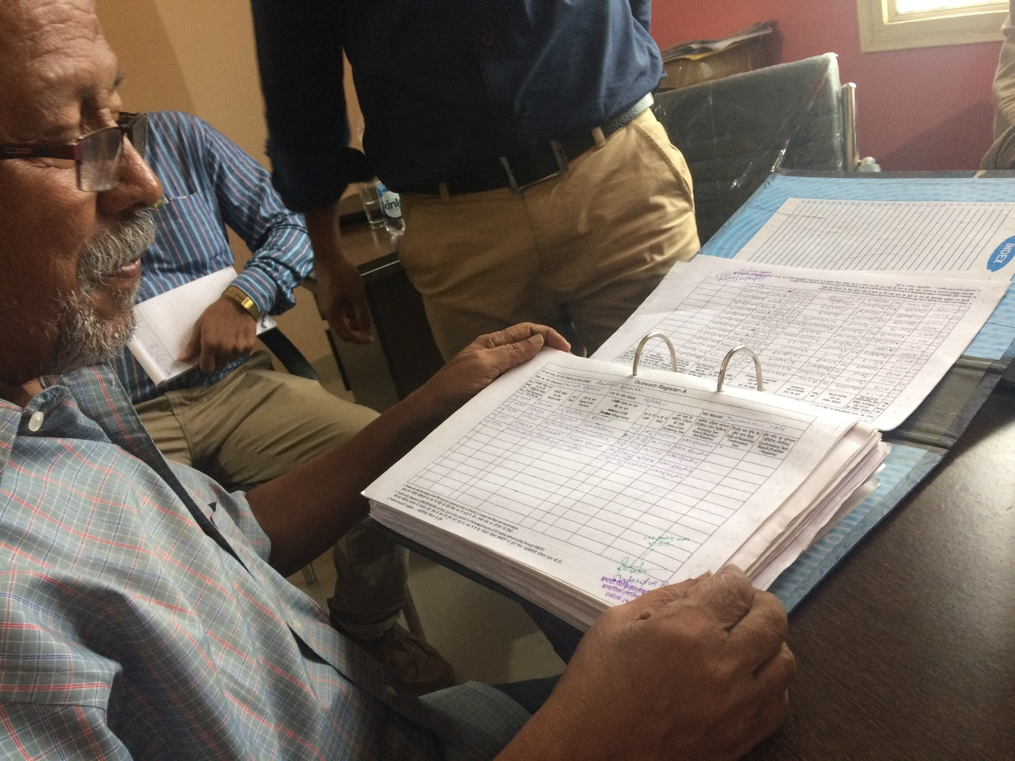
Verification of the register at Patna at office of the SR
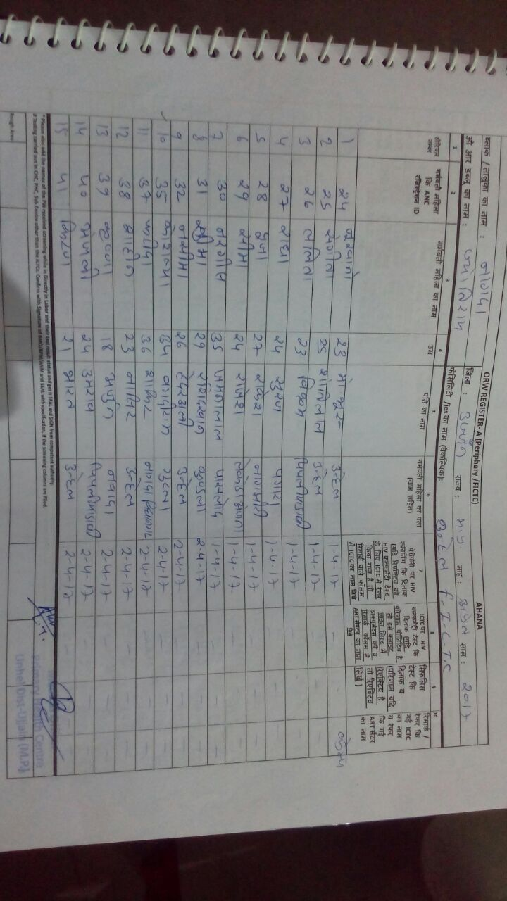
The Register at Ujjain

5.8.8 Data validations visits are made by the members of the SR team and also by the member of PMU not only to validate the data in the field but also to ensure the integrity of the data and to guide the lower formation in maintenance and reporting of the data in proper manner. During such visits they check all the records and data A number of visits had been made by SR in Madhya Pradesh but only few visits are made in Bihar, in Assam and Chhattisgarh. In Odisha in one case in the field there was an error in the serial numbers in the register, the register checked in the filed were not up to date. Mostly the data entries are correctly made.
5.8.9 At the district level proper capture of event, up-to-date ness and completeness of the registers are being checked. Recounting of the entries in the registers are made to check the correctness of originally reported figures. The reported figures and the figures entered in electronic media are also checked. Wherever there is any possibility of cross checking the data with other sources the same is also carried out. At SR level review of timeliness and completeness of reports from district for the reporting period are checked. Numbers submitted by the District are re aggregated and compared with the numbers submitted to the next level. Variation if any are identified and the reasons are looked into for remedial measures. At PMU level the monthly reports are checked and reconciled.
6.8.8 Availability, completeness and Timeliness of Report is calculated in term of percentage of reports that comply with the requirements against the total number of reports received. Accuracy is measured through correction factor which will be the ratio of the recounted value of the indicator to the reported value.

7. Conclusions and recommendations.
7.1 The concussions and recommendations are given under has two parts one is sate specific and the other Is generic
7.2 State specific recommendations.
- Madhya Pradesh may think of formulating a high power committee to look into proper coordination of all work related to PPTCT services. It may also think of formulating the SARC in the State,
- Jharkhand may also form the SARC at the earliest
- Madhya Pradesh may also form the DAC in all the Districts.
- Madhya Pradesh and West Bengal may take up the training of Peripheral health workers at the earliest
- Madhya Pradesh and Uttar Pradesh may pay more attention to BCC activities and put up wall paintings and conduct Nukkad Nataks.
- West Bengal may pay more attention to organise Nukkad Nataks
- Rajasthan, Bihar, Assam and UP may give expose their health staff to the BCC activities.
- Rajasthan may take more publicity measures aiming to reduce stigma in remote rural areas.
- Jharkhand, West Bengal and Bihar may appraise all the team members thoroughly about the programme
- Assam and Bihar may give more attention to Index three. The difficulties if any have to be discussed and the progress has to be pushed up.
- Uttar Pradesh has to think very seriously to improve their progress w.r.t. index no. 1. They should take up measures on a war footing basis.
- Rajasthan and West Bengal may pay more attention to have more number of mobilisation meetings.
- Assam Bihar and Chhattisgarh SR may make more number of field visits
- Bihar may pay more attention to submission of records in time.
- MP may adopt the ORW Register A format as available in the guidelines
- The example of Supaul district in Bihar roping in the media for complete coverage of the activities related to PPTCT services may be followed by others
7.3 The general recommendations.
- The study identifies a risk that, unless facility is expanded the programme will continue to suffer in this component. States may also think of establishing EID centres and more number of ART Centres in each of the states.
- AHANA guideline is a lengthy document. Some of the important aspects of guide lines can be prepared in bullet form and hung at the offices of the stake holders.
- The state management units at the SR level needs to be more proactive in monitoring and supervision of the field activities.
- Field level staff should be given a brief task chart about the care and support activities needs to be carried out with the HIV positive pregnant women.
- Trainings should be provided in regional languages to increase effectiveness. There should also be a manual translated in vernacular languages.
- It has been generally felt that there should be periodical refresher training for the programme staffs.
- There should be mechanism to induct newly recruited peripheral health workers under DRT curriculum and there should be induction course on a regular basis for the new incumbents.
- The ASHAs and the Anganwadi workers can also be roped in for training.
- Inter personal communication may be made as part of the curriculum for training
- Paintings could be made more attractive and catchier. Nataks could be evenly spread over time and space.
- As a part of IEC /BCC activates pamphlets, bit notices can be printed and distributed.
- Hoardings can be erected at impotent places where peoples normally used to crowd. Visual aids may adopted for these activities as they may have a better effect.
- There should be norms prescribed for wall paintings so that they are posted in the right locations and also walls not painted side by side.
- Periodical meetings of all stake holders at different level could be held for dissemination of up to date information, exchange of ideas and charting our further strategies for still better achievement.
- Governance mechanism including SARC and DAC meetings needs strengthening as few of the states lagging behind in implementing these events.
- Periodical bulletin can be prepared and circulated to all stake holders, to increase the visibility and also the ownership.
- The data reporting could be more dynamic or real time basis with the help of the dedicated network for the purpose from the point of origin of the data as and when an event occurs. To avoid the chances of duplication linkages of ADHAAR CARD could be explored.
- The states may ensure that the health facilities at the district level at least have all facilities and the patients are not driven out to purchase kits.
- The scheme may need more number ground level staff.

7. Limitations.
71 There had been some law and order situation in the field due to which we could not cover some of the districts originally selected and had to make substitutes
7.2 All the stake holders could not give information on all the aspects on which we had tried to collect the information as some of them are not much related to some of the information to be collected.
7.3 The early part of the field work was Polio week and as such we had difficulties in the field in contacting the health officials and peripheral workers who were all busy with Polio week
7.4 Some SR were busy with recruitment work and could not give any time before 10th July 2017 though the work has been started from 3rd July.
7.5 Some of the officials were not available in spite of repeated appointments /visits.
7.6 There were no PPWs at all or only one PPW in a district as such we could not cover the quota of PPWs in some of the districts.

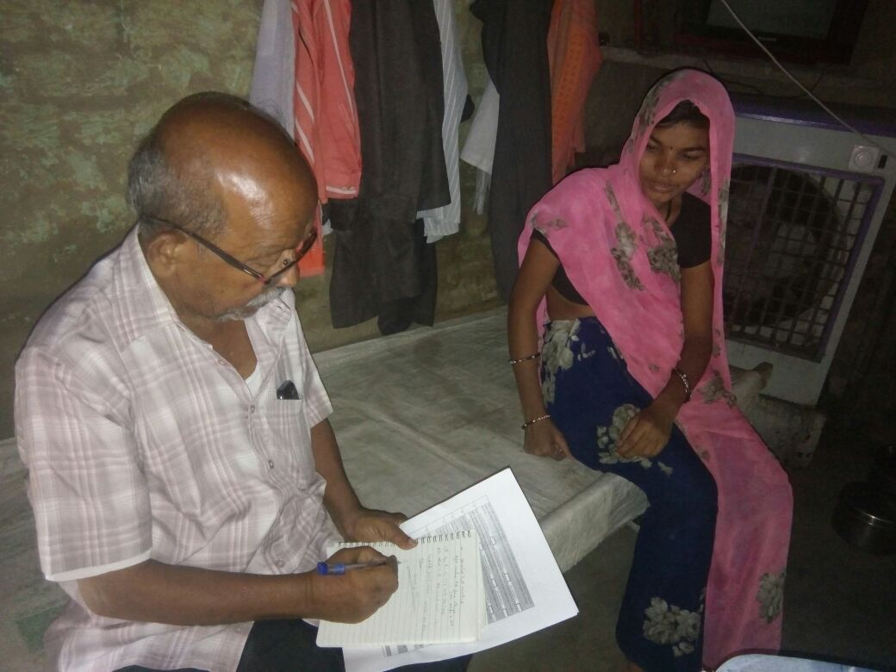
With a PPW in Bihar
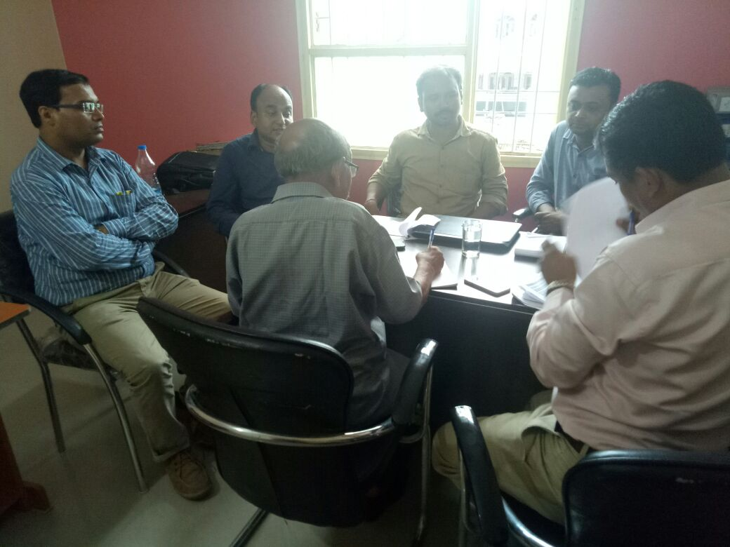
Discussion with SR Team
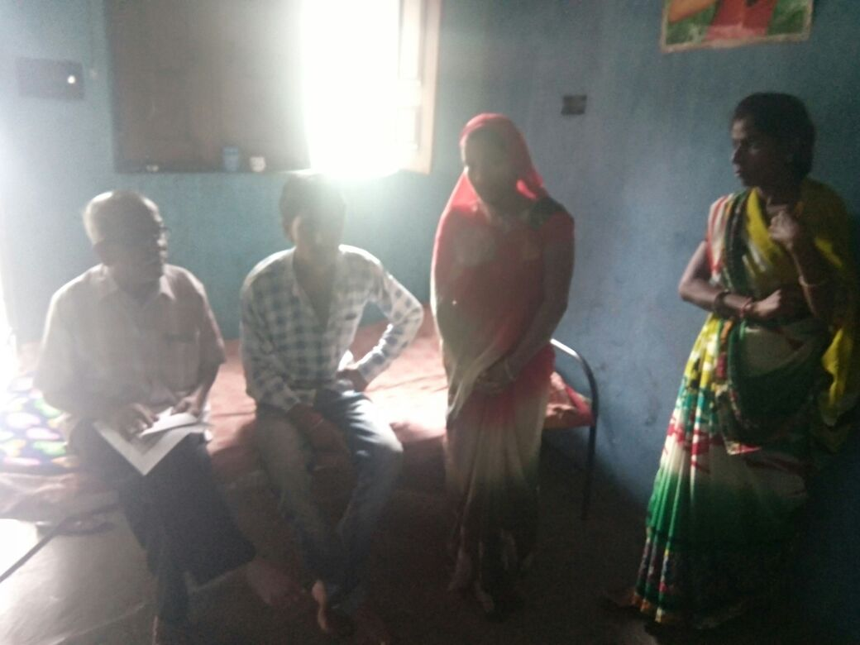am with PPW family at the time of interview.
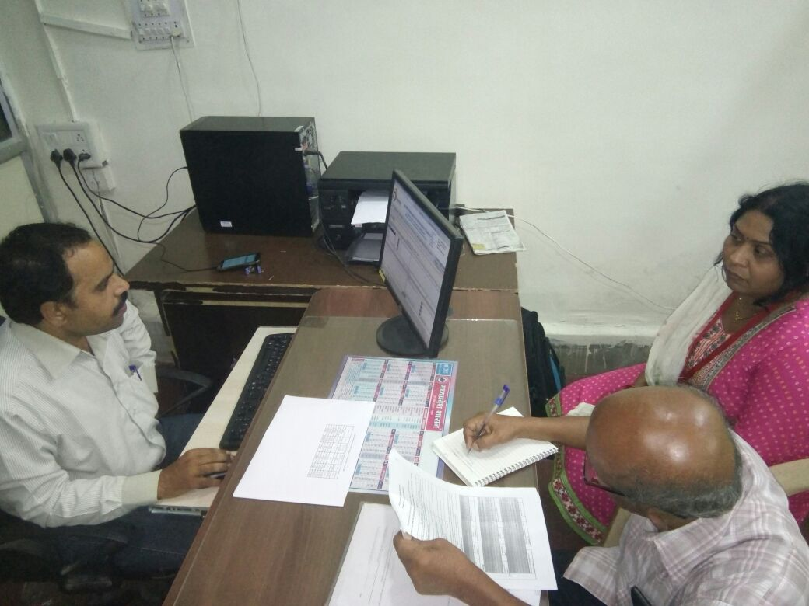
At Sadar hospital Dewas with DO
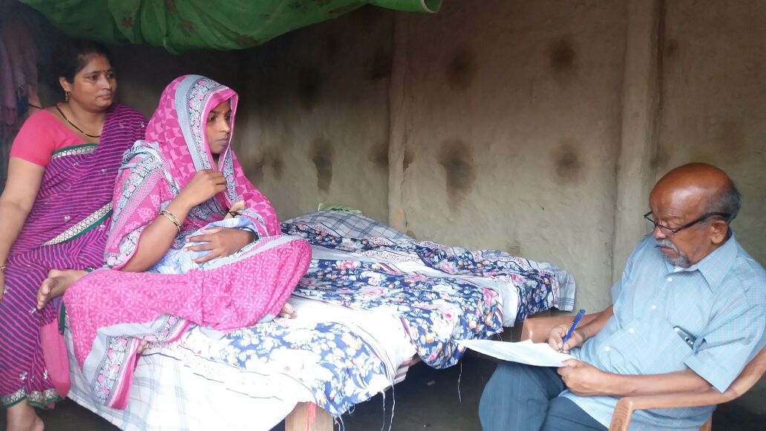
With PPW at Supaul district
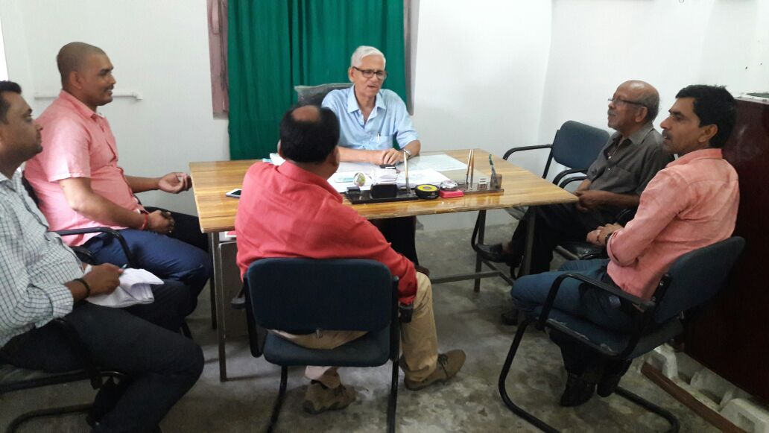
With MO at Dalsingsarai PHC in Samastipur Bihar

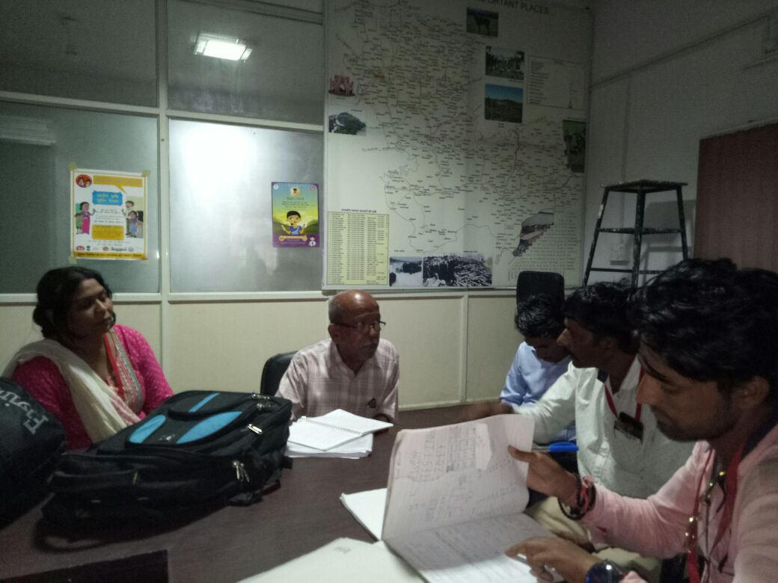
AHANA team of DEWAS
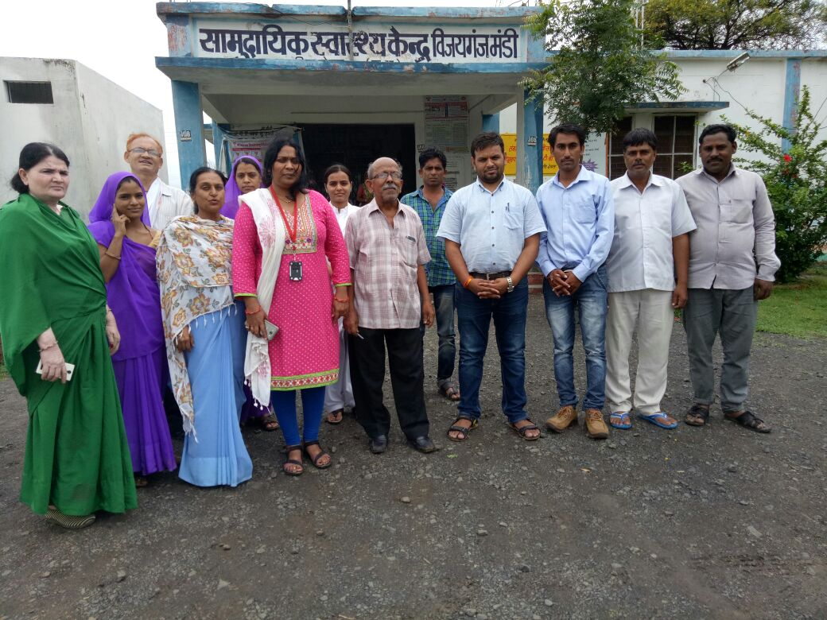
AT PHC VIjayaganj Mandi, Dewas district with staff and persons Interviewed.
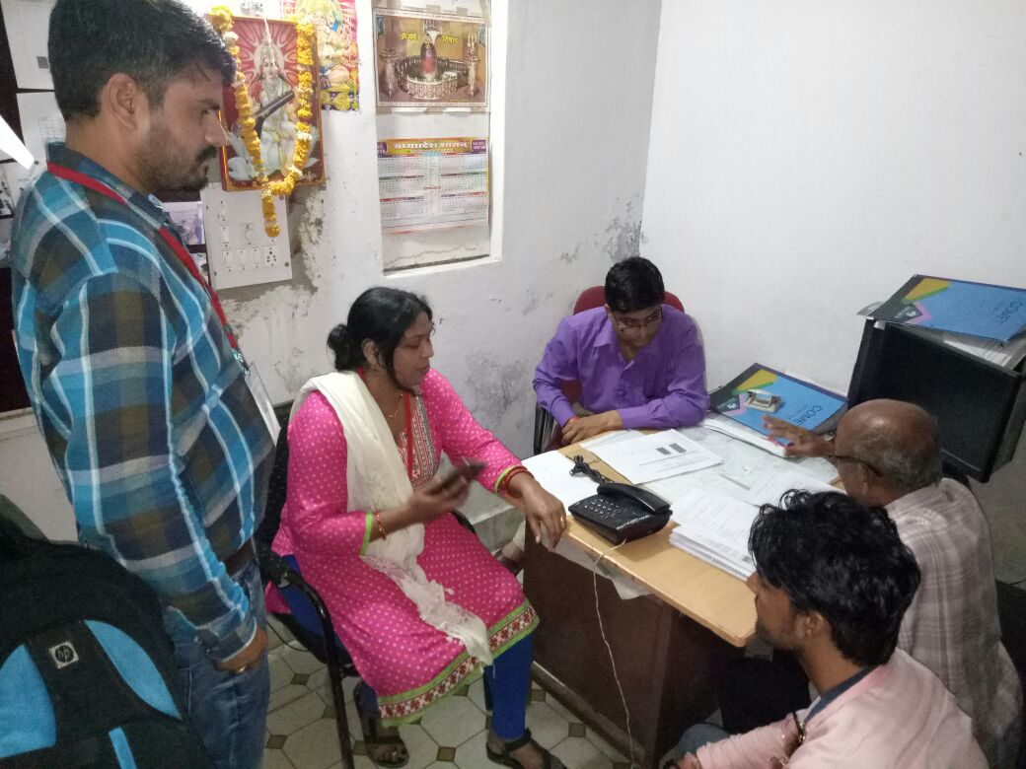
Interview at Sadar Hospital Dewas
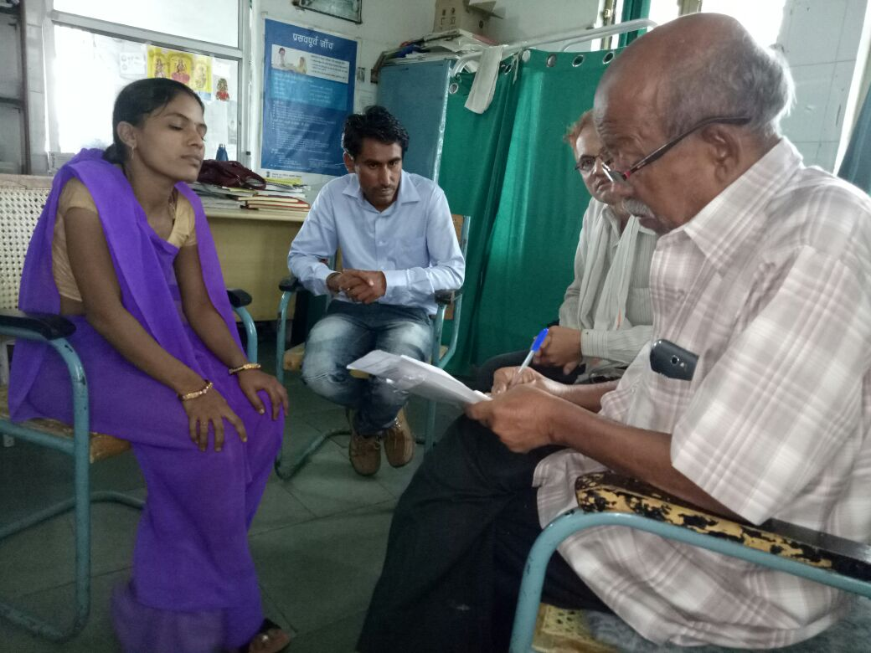
With a peripheral worker at Vijayganjmandi PHC
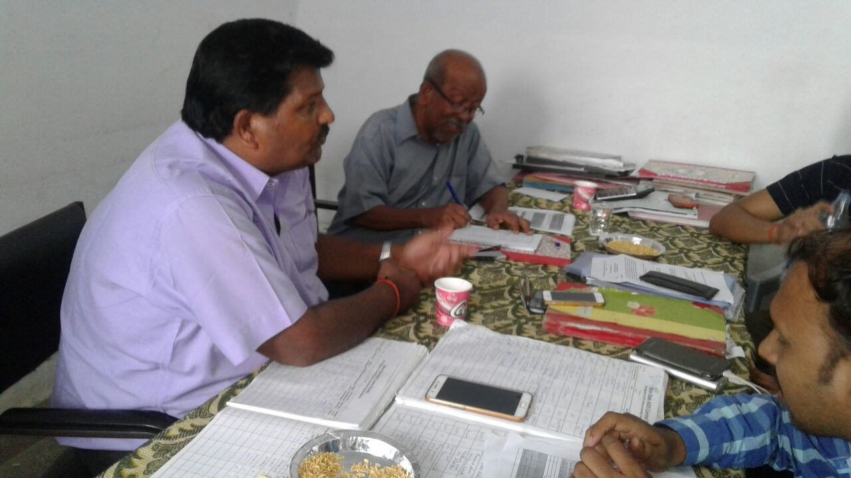
With pptct counsellor, Supaul
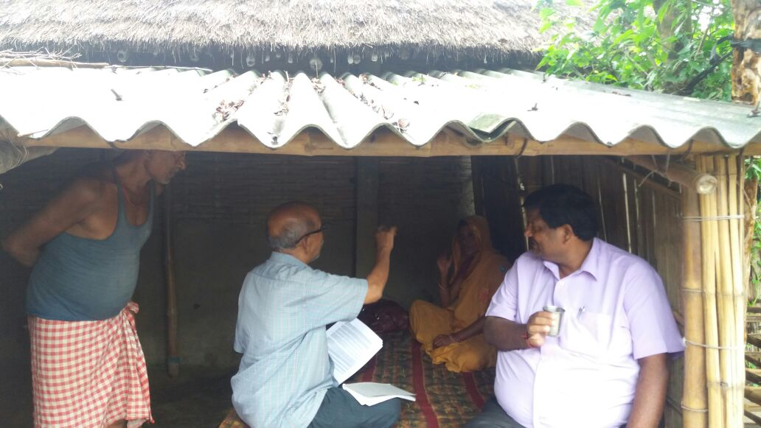

With a PPW at Supaul
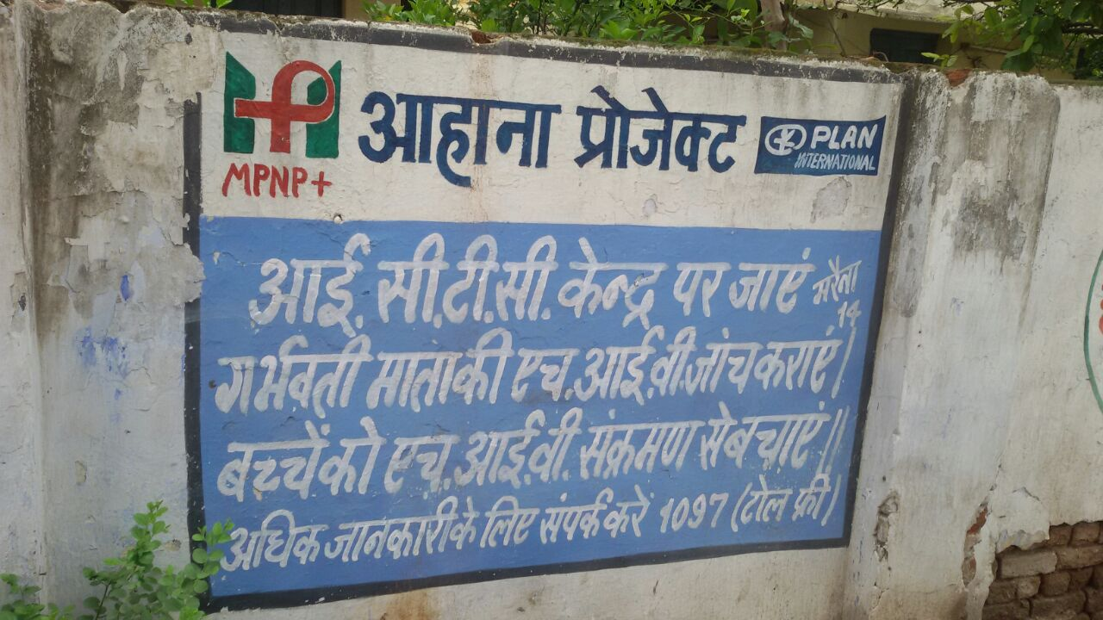
A wall painting in MP
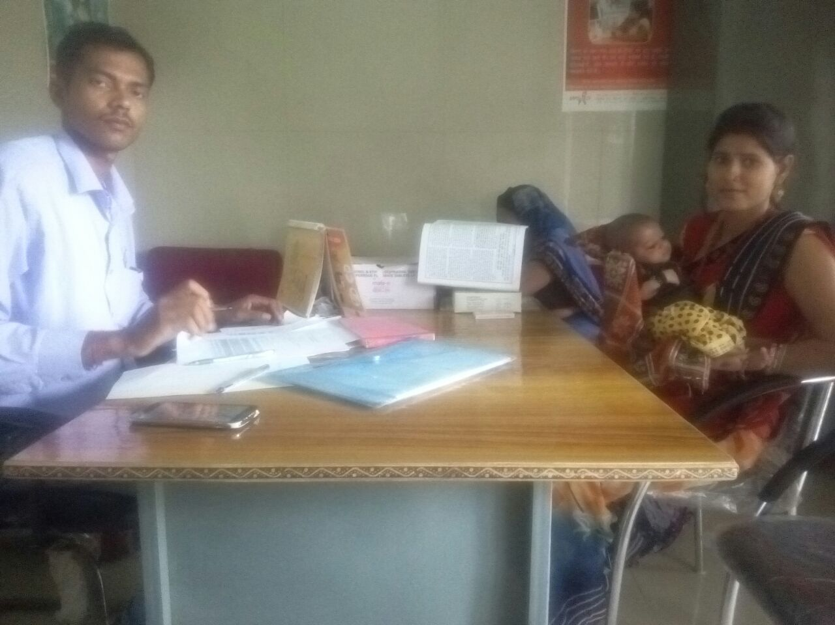
Our consultant with a PPW at MP
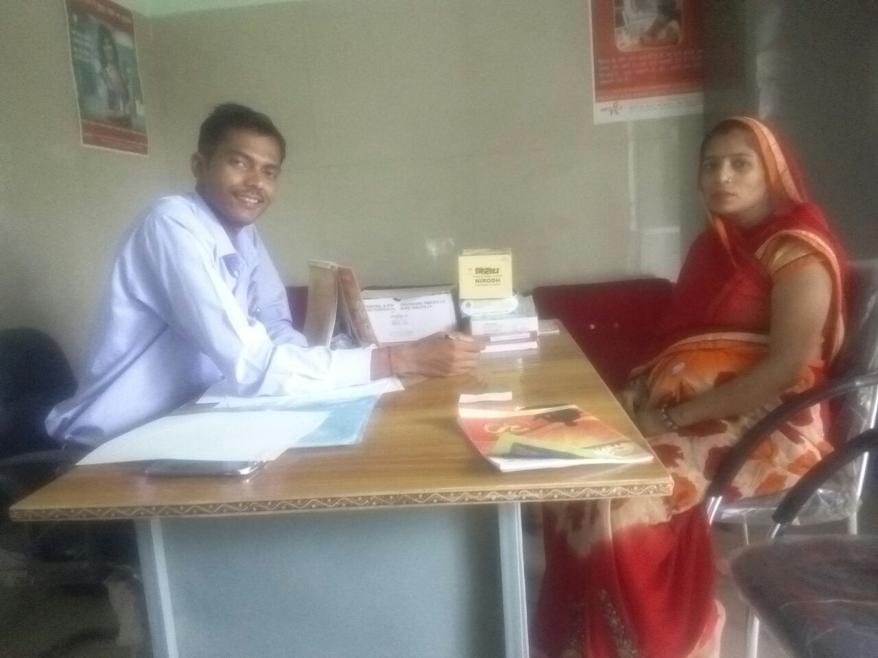
Our consltnt with a PPW at MP
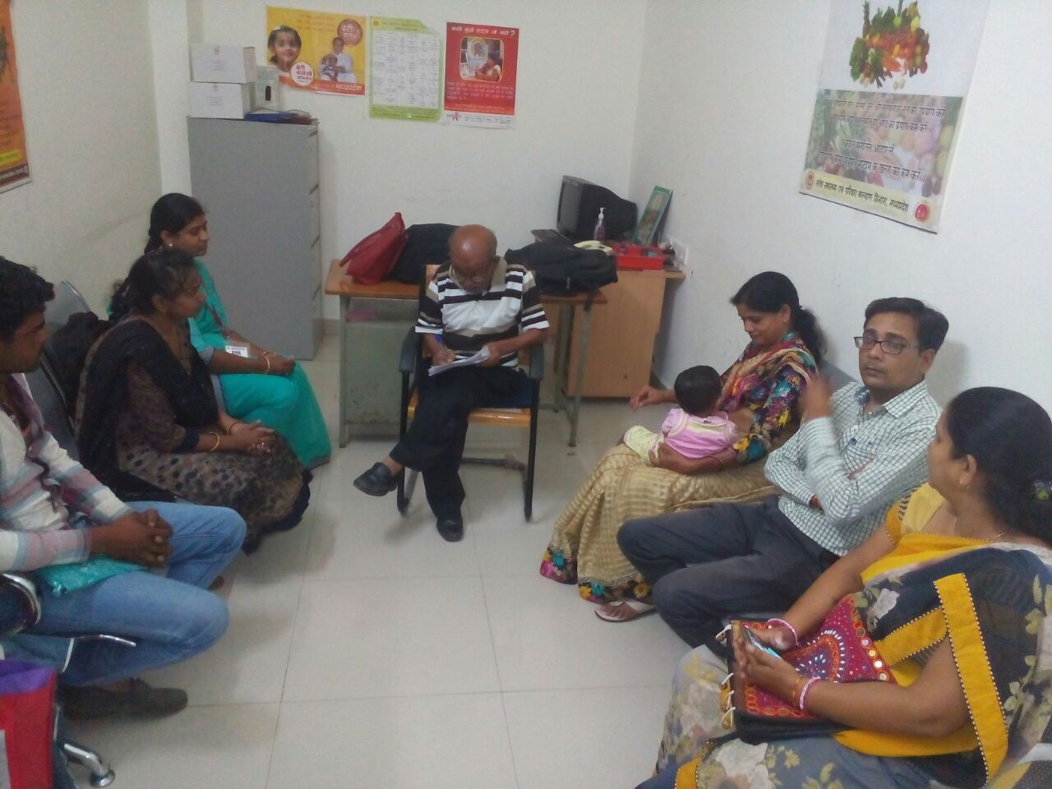
Interview of PPWs at Ujjain

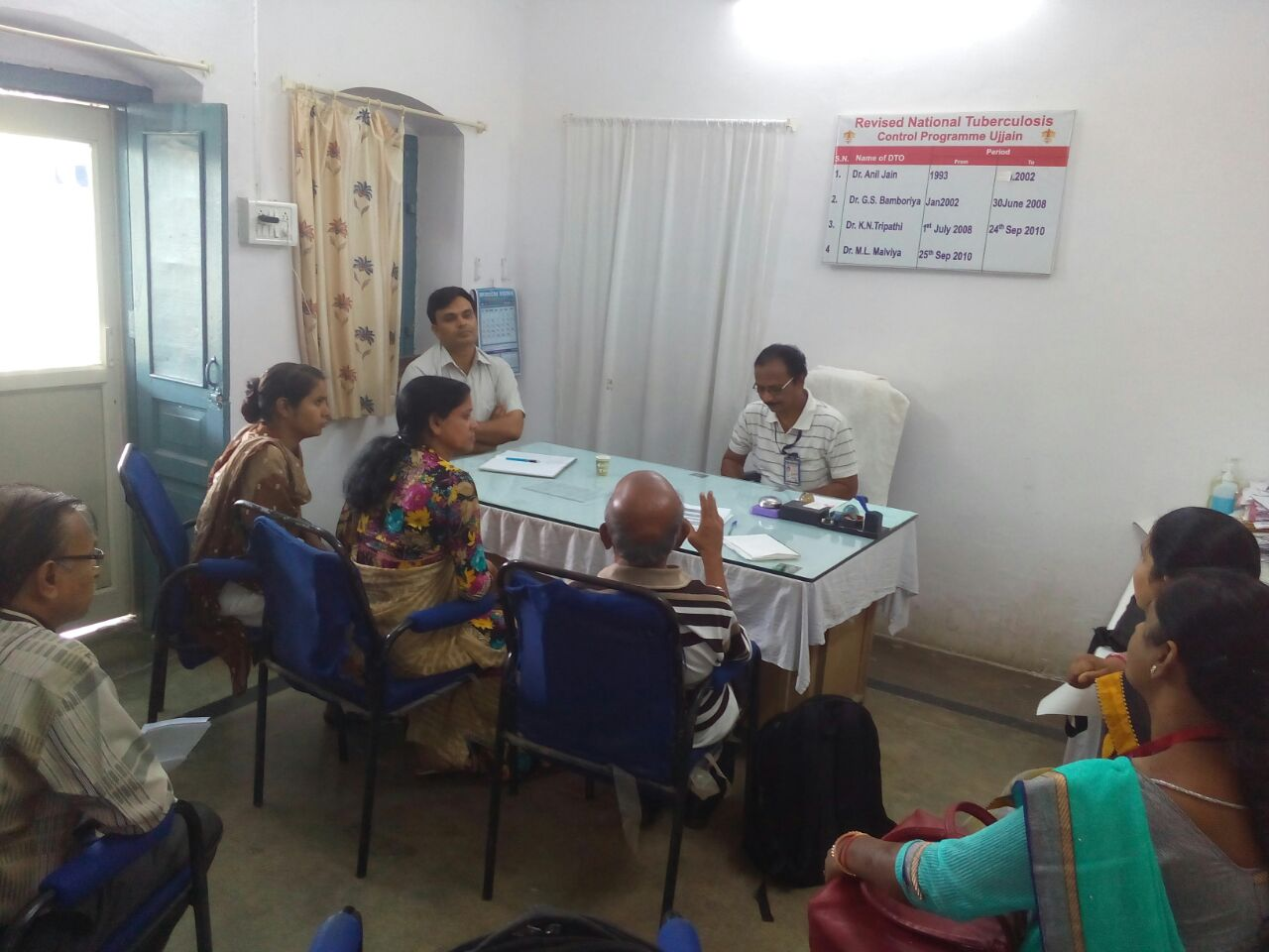
Interview of DOT & nodal officer Sadar hospital Ujjain
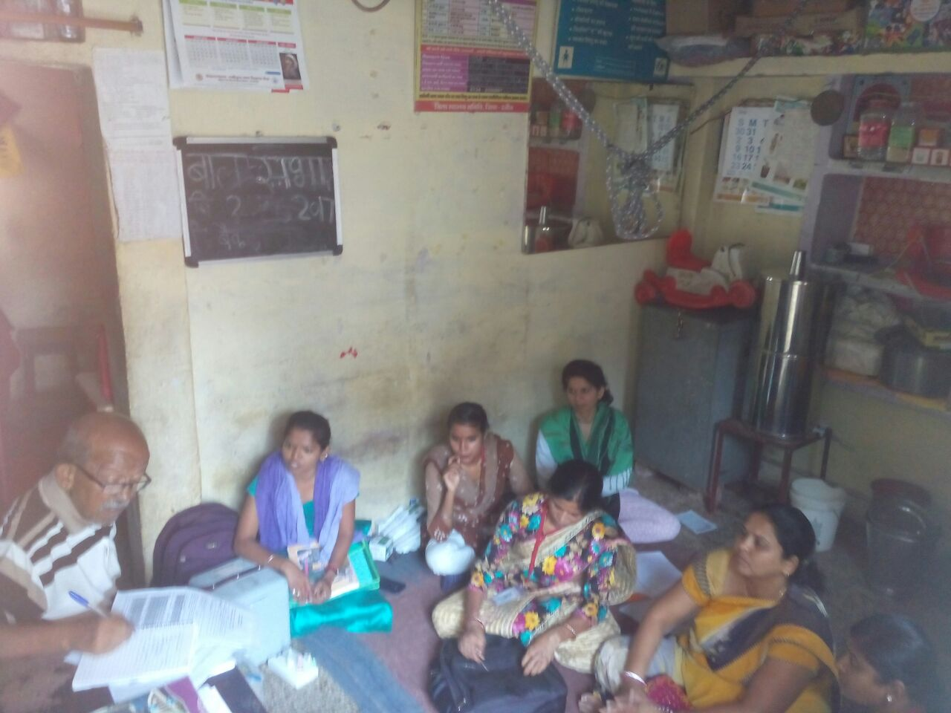
Interview of ANM at Anganwadi centre Ujjain

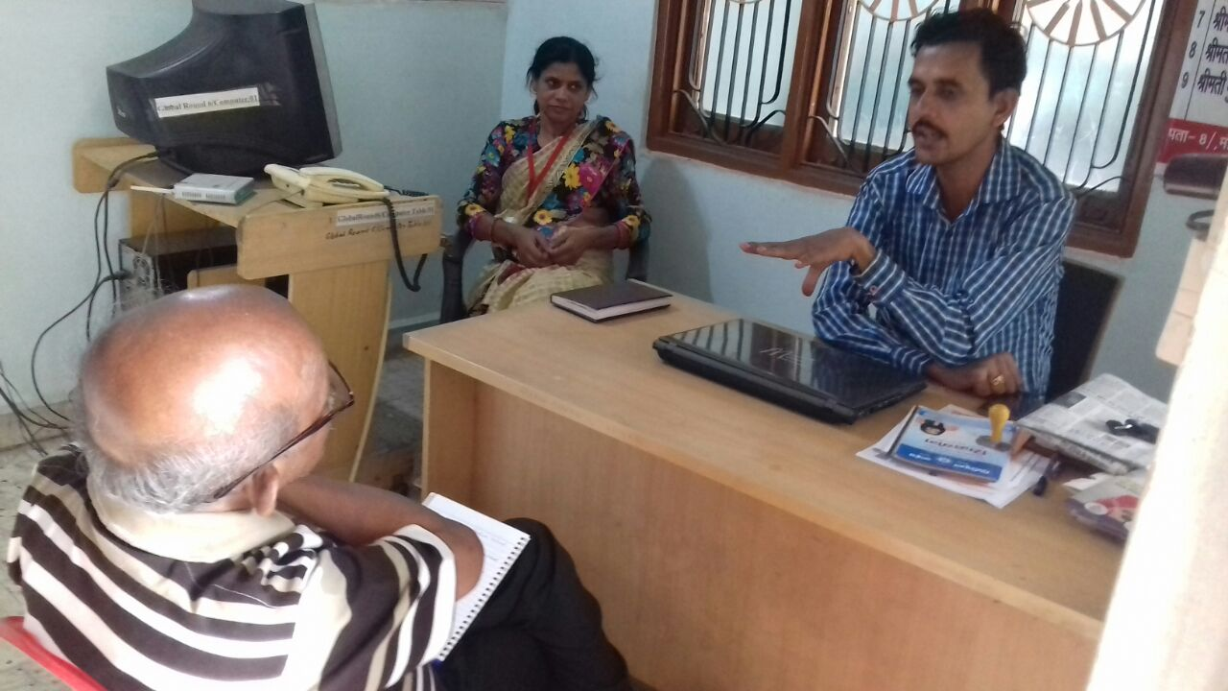
Interview at Ujjain DO in the background.
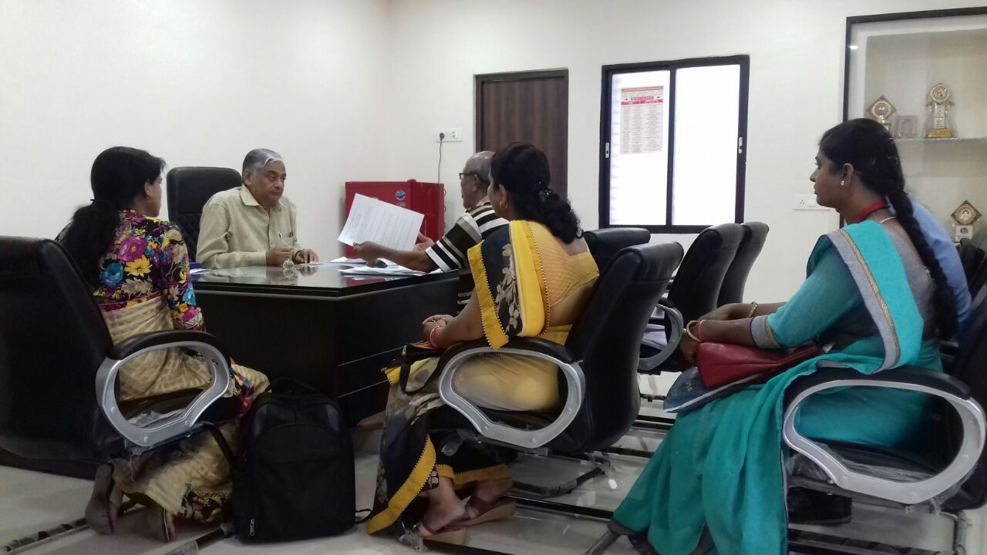
With CS Ujjain
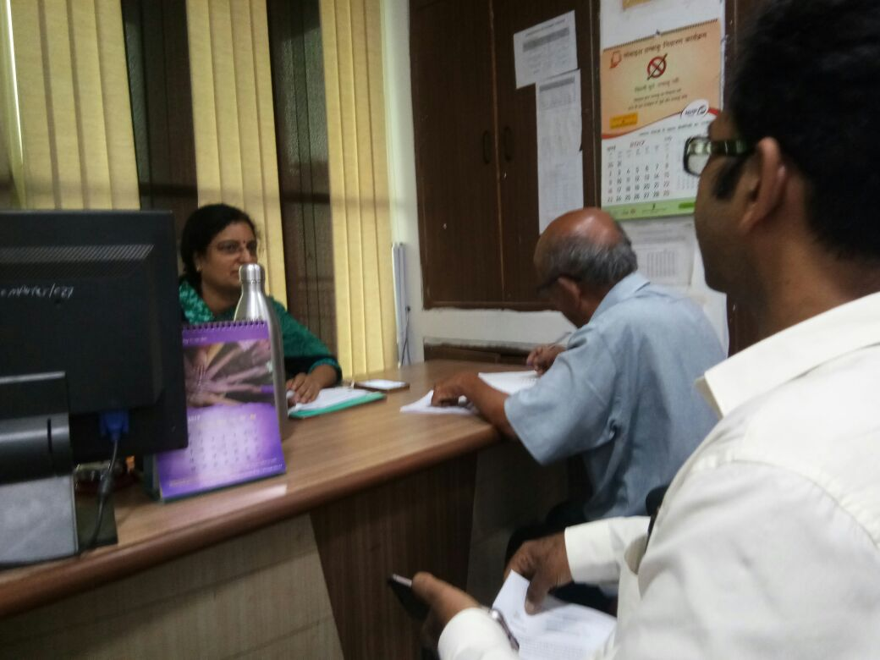
With DD, Maternity Health, NHM Bopal
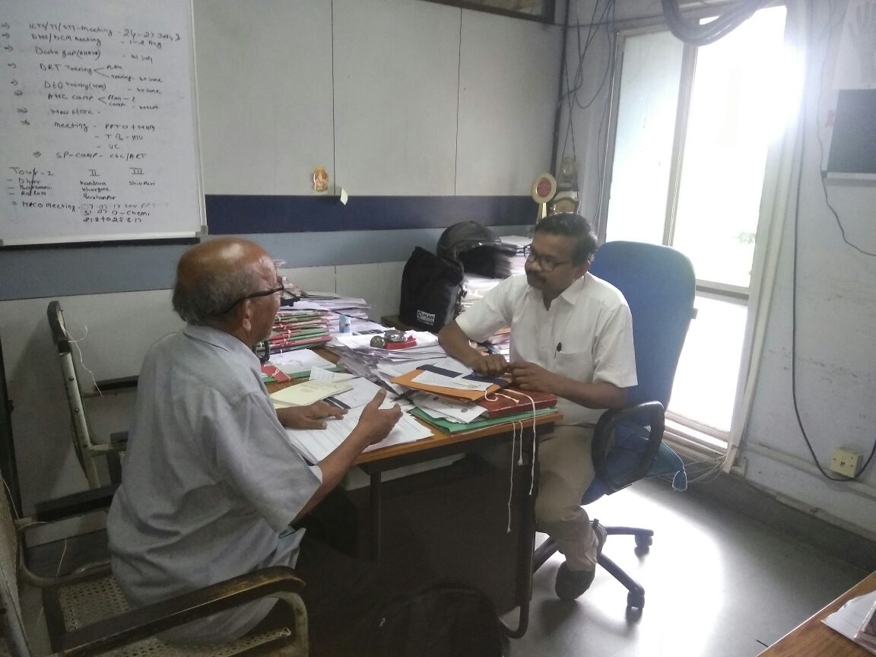
With SACS official at Bhopal
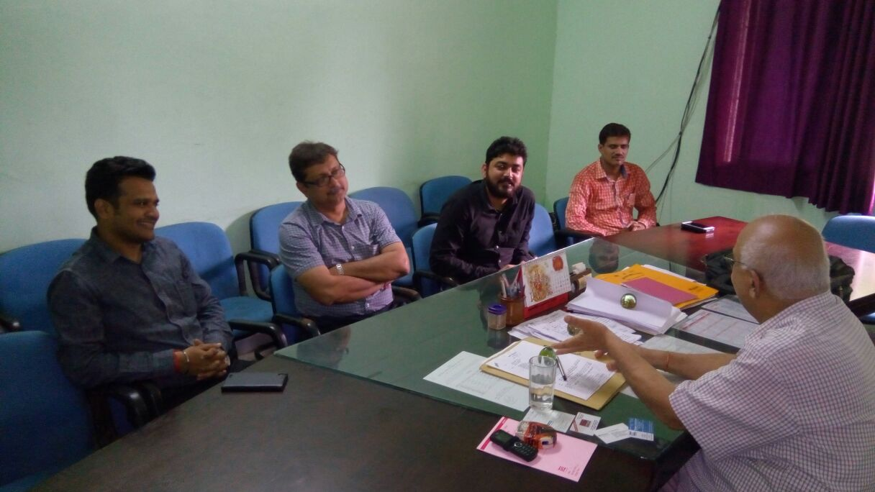
Our consultant MO hit (with beard) at Jharkhand
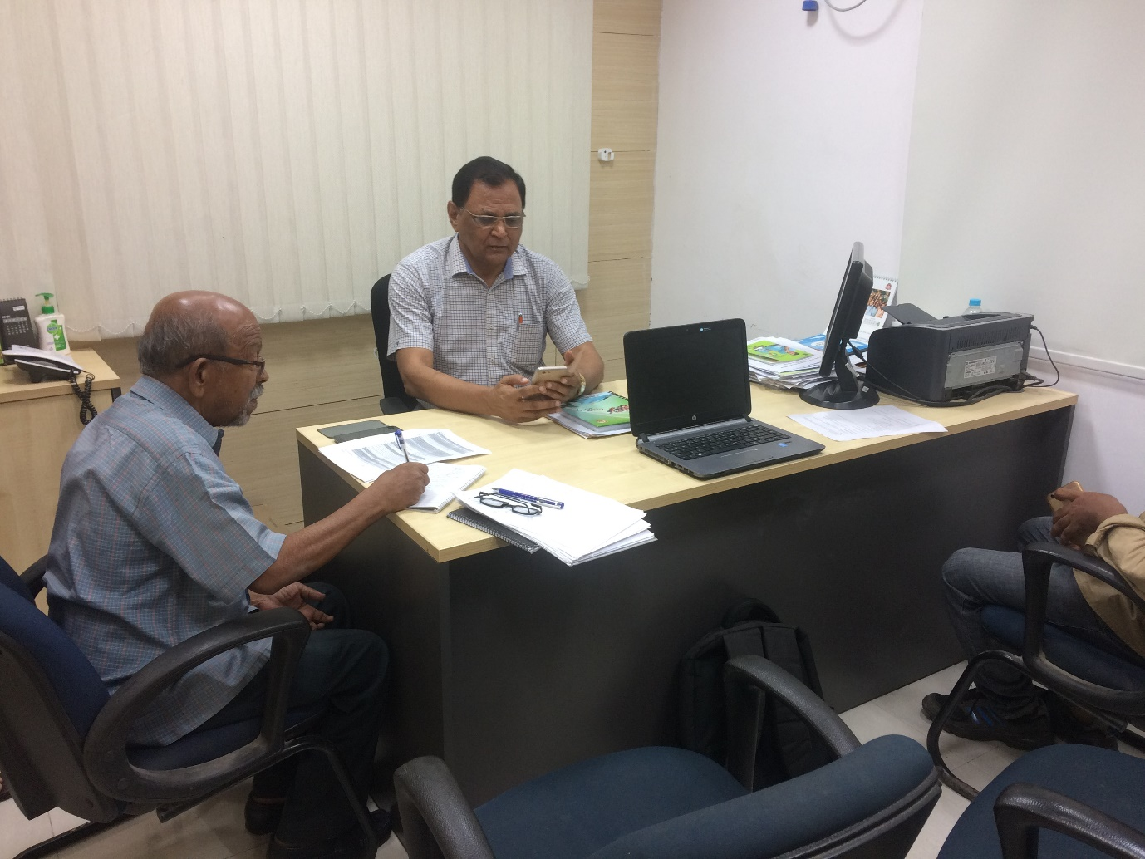
With Dr. Phuleshwar Jha at Patna
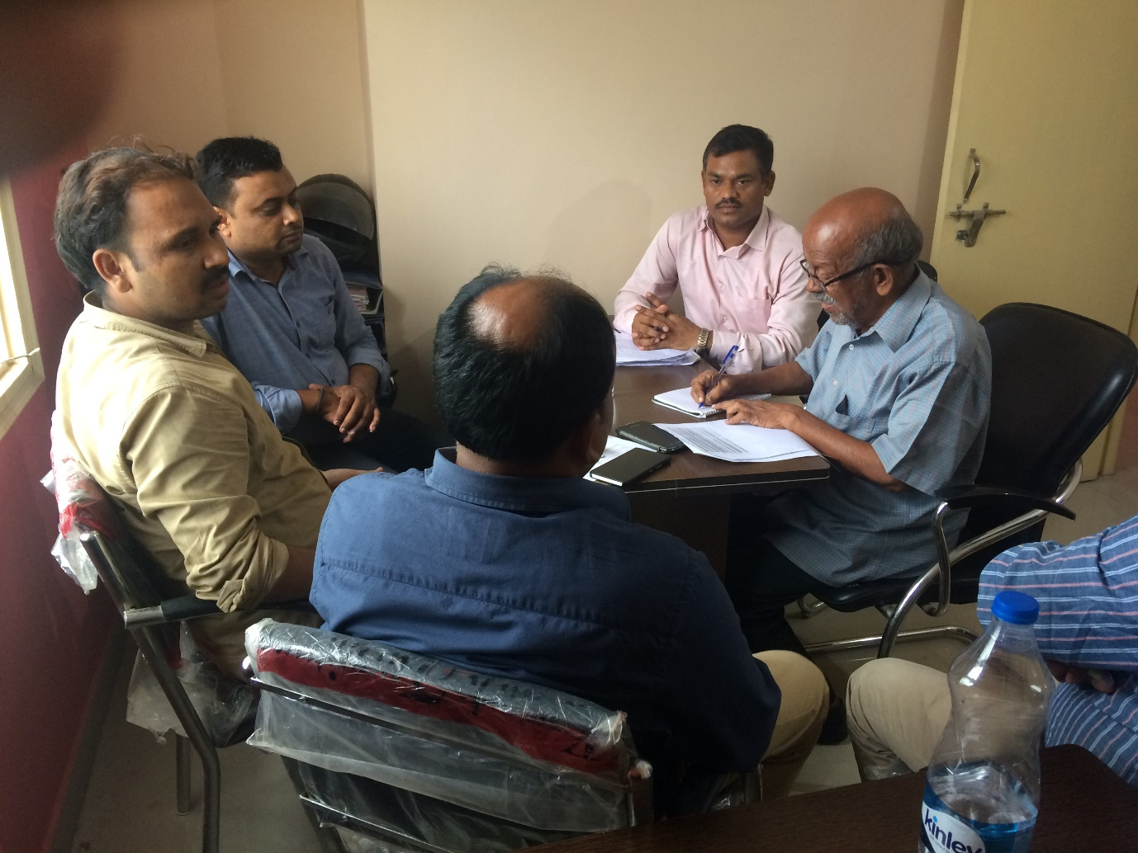
With SR team at Patna

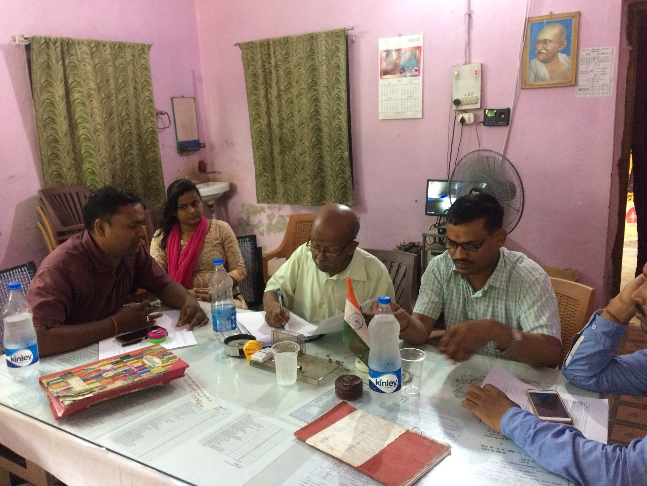
With Mr. Viod Kmar Sha BPM, Darbhanga.

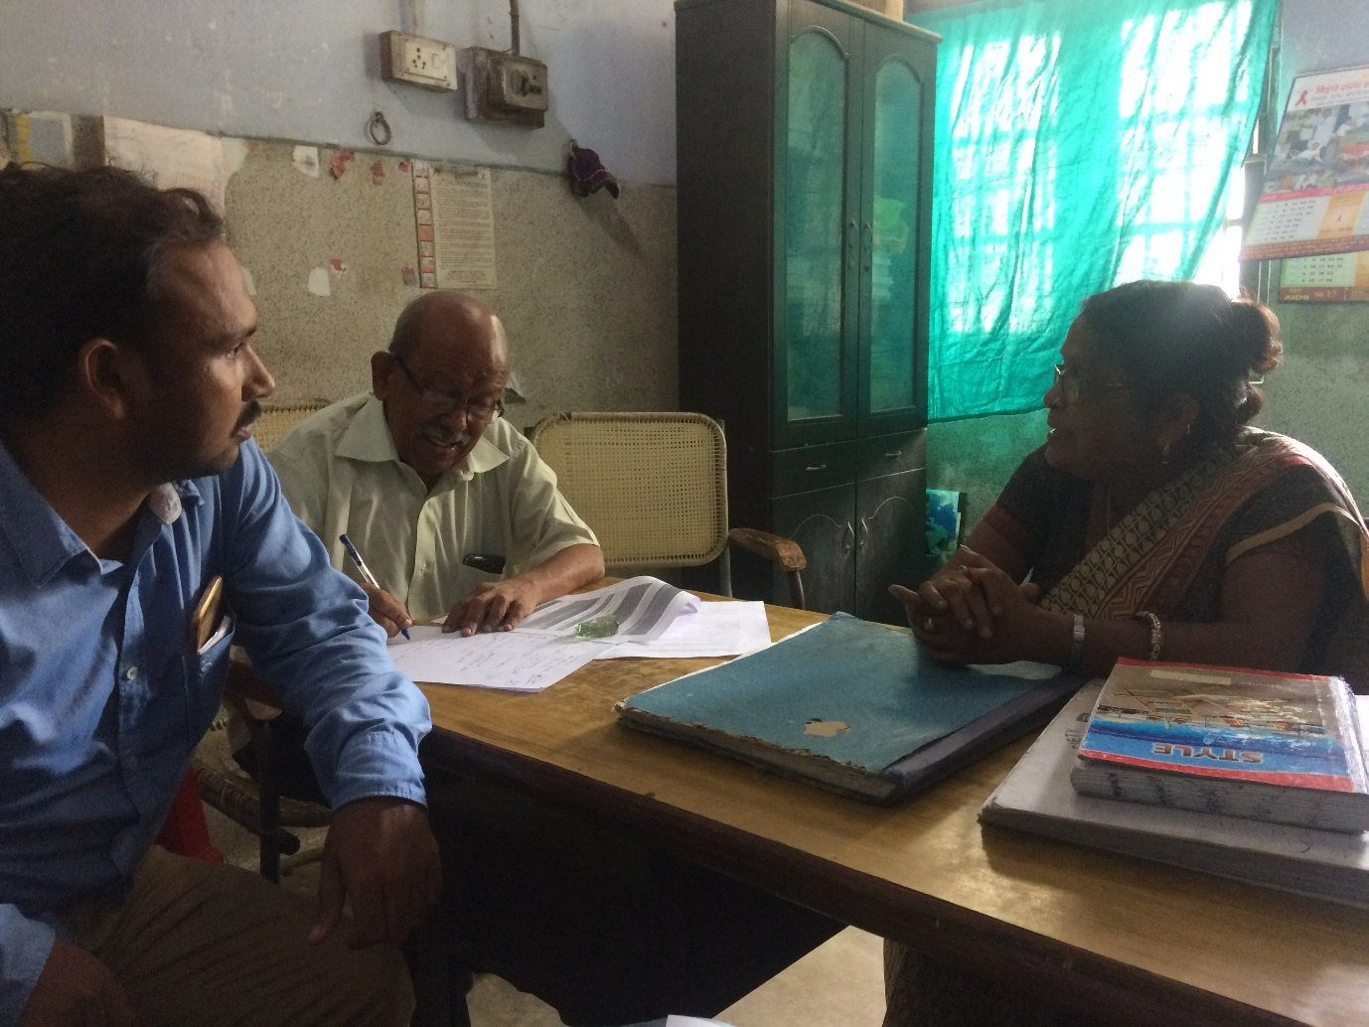

With ICTC counsellor, Darbhanga.
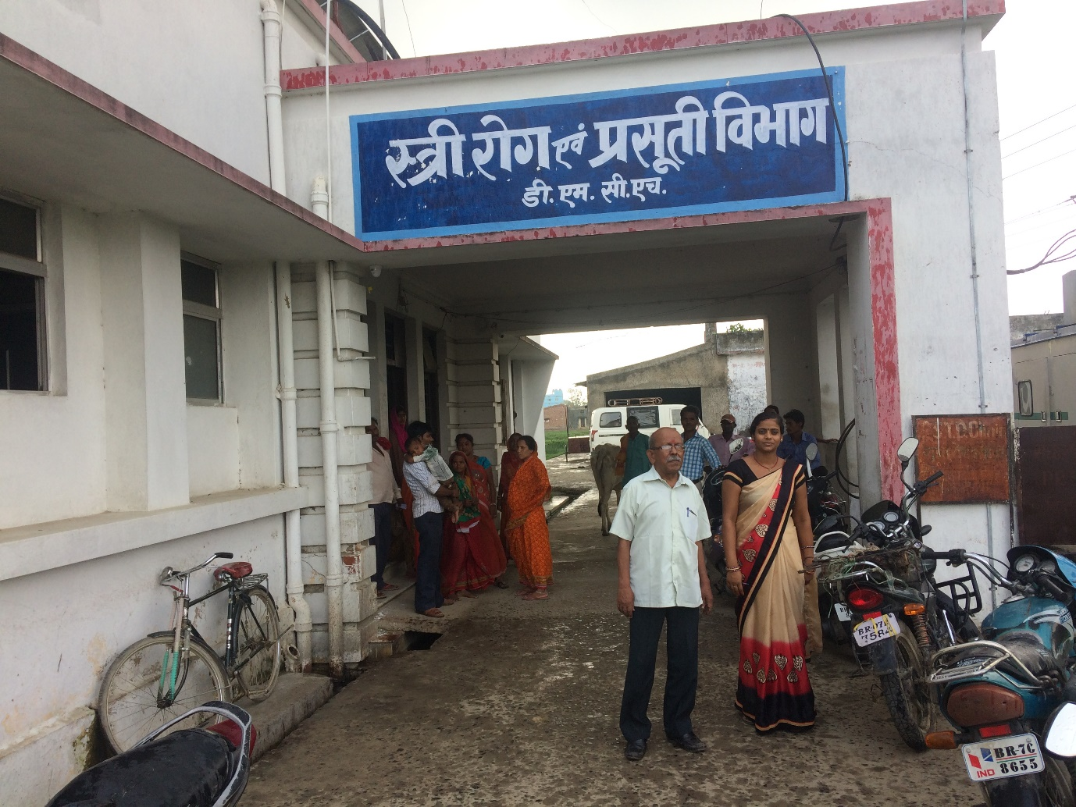
In the hospital premises with ORW
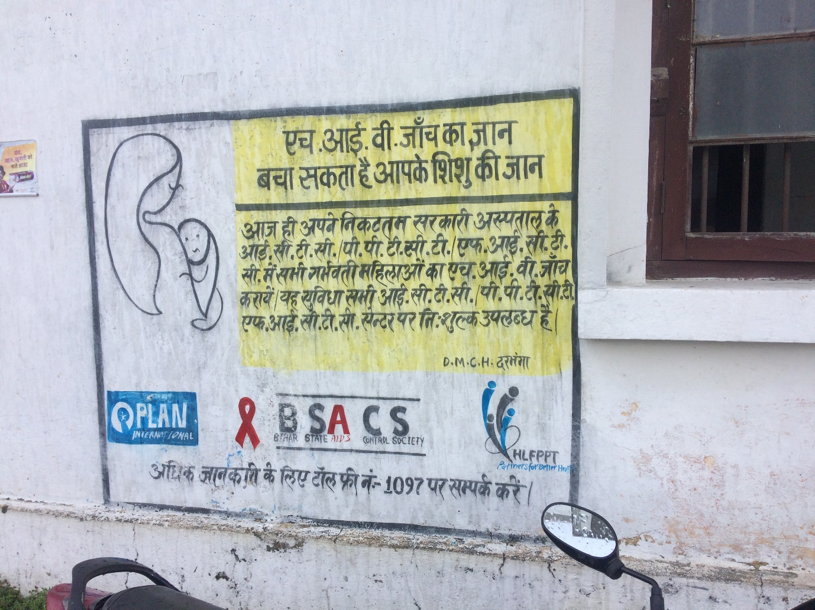
Wall paintings at Darbhanga
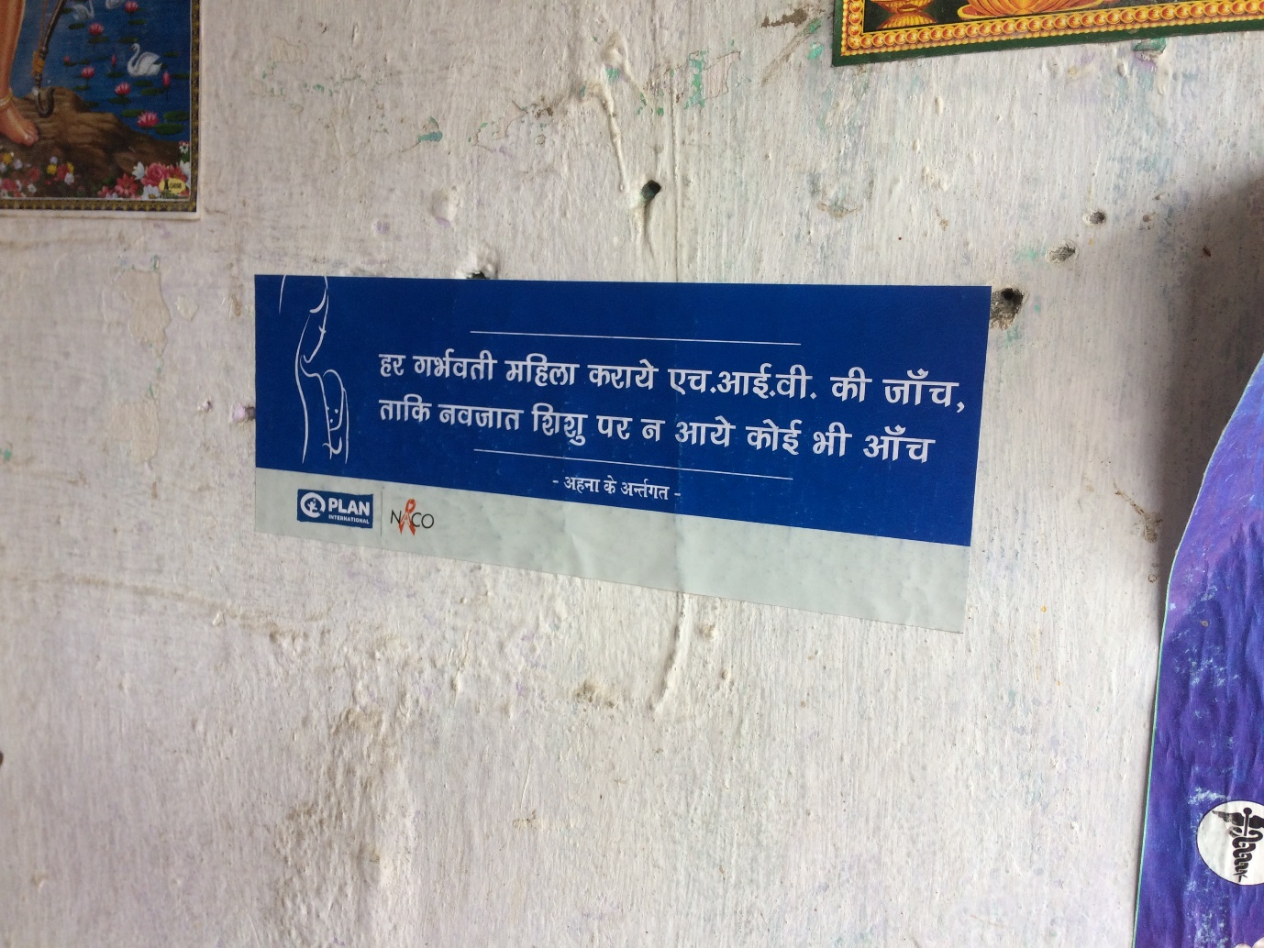
A poster in a PHC at Khagaria district,
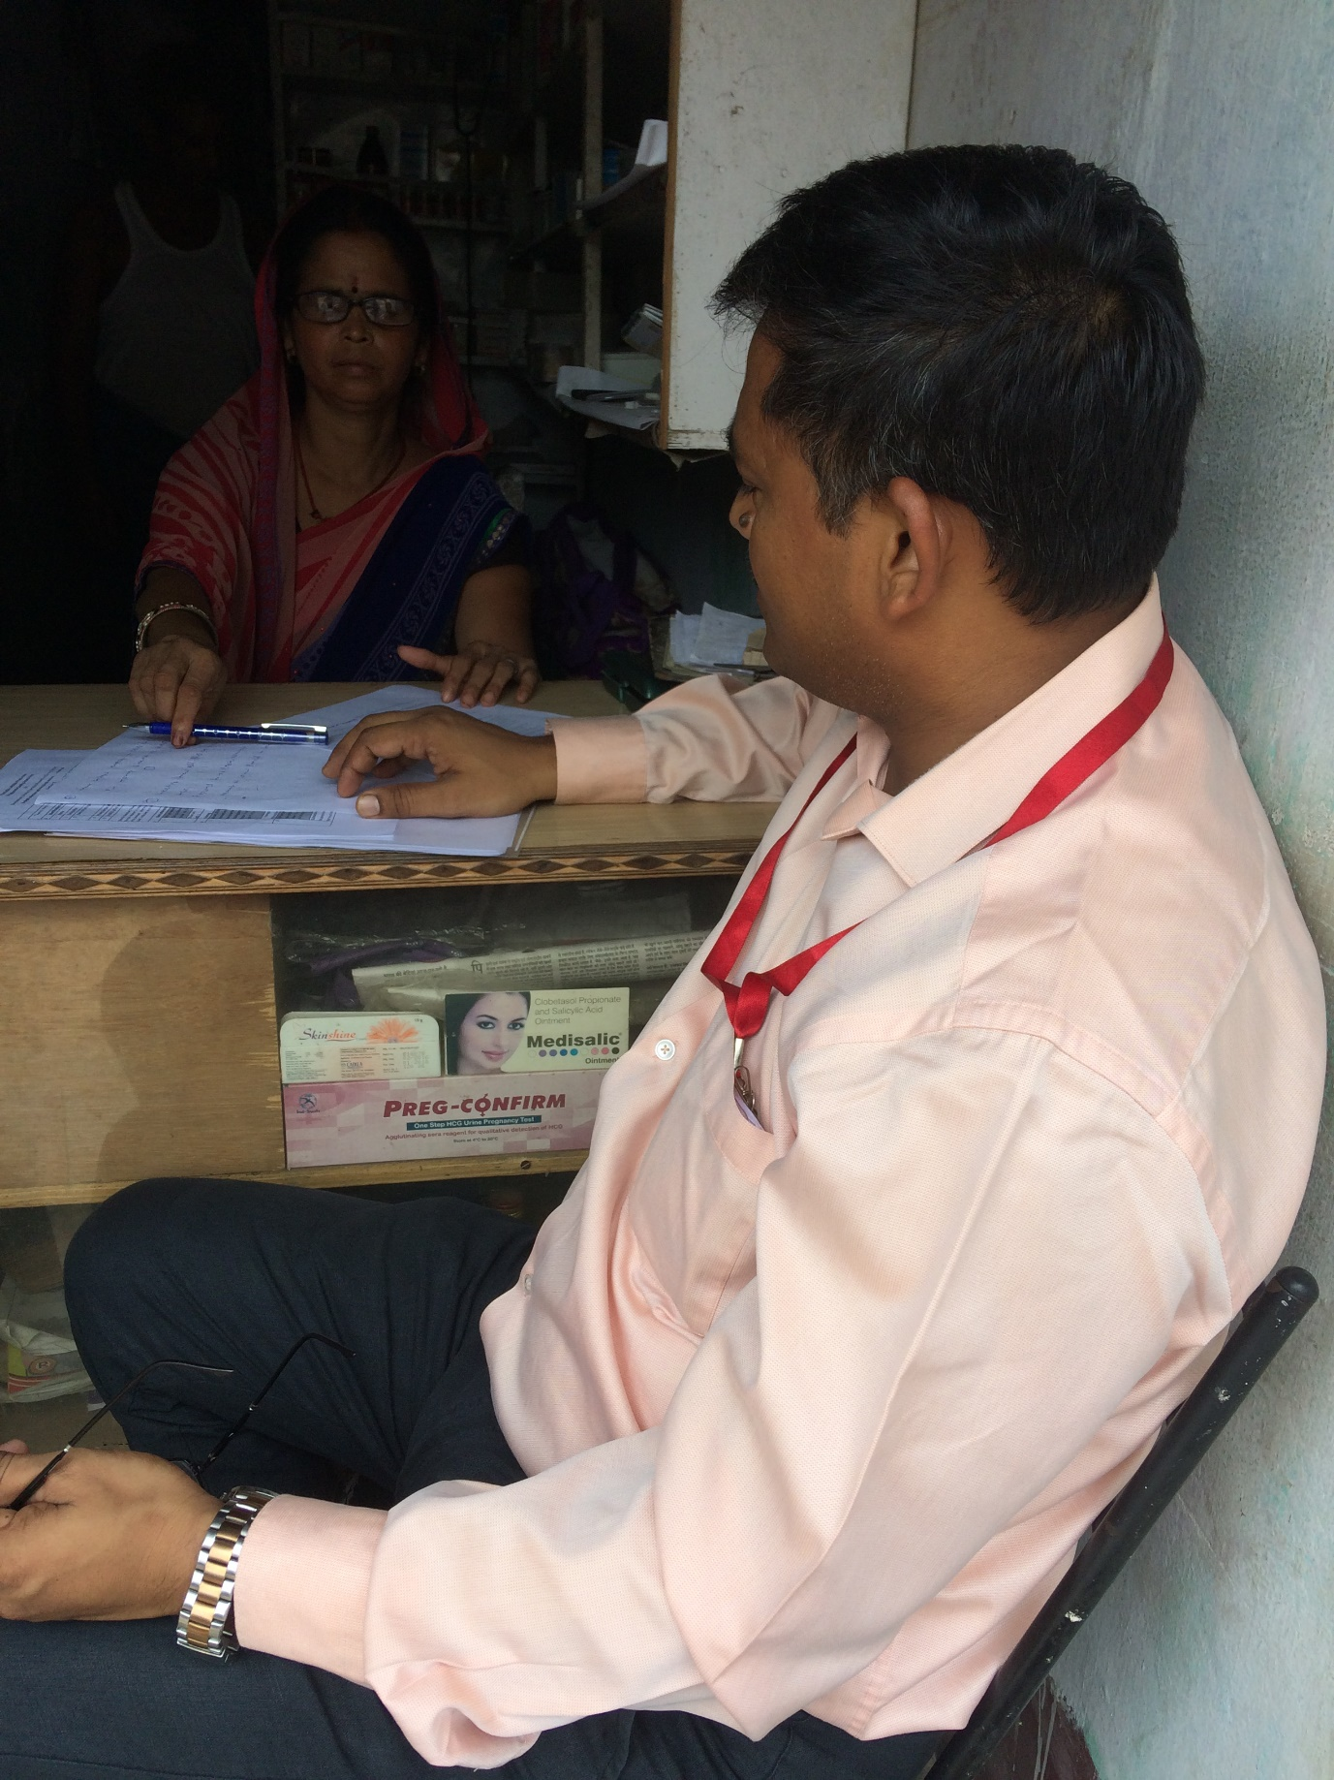
Interview of ASHA in a PHV are in the field in Khagaria district
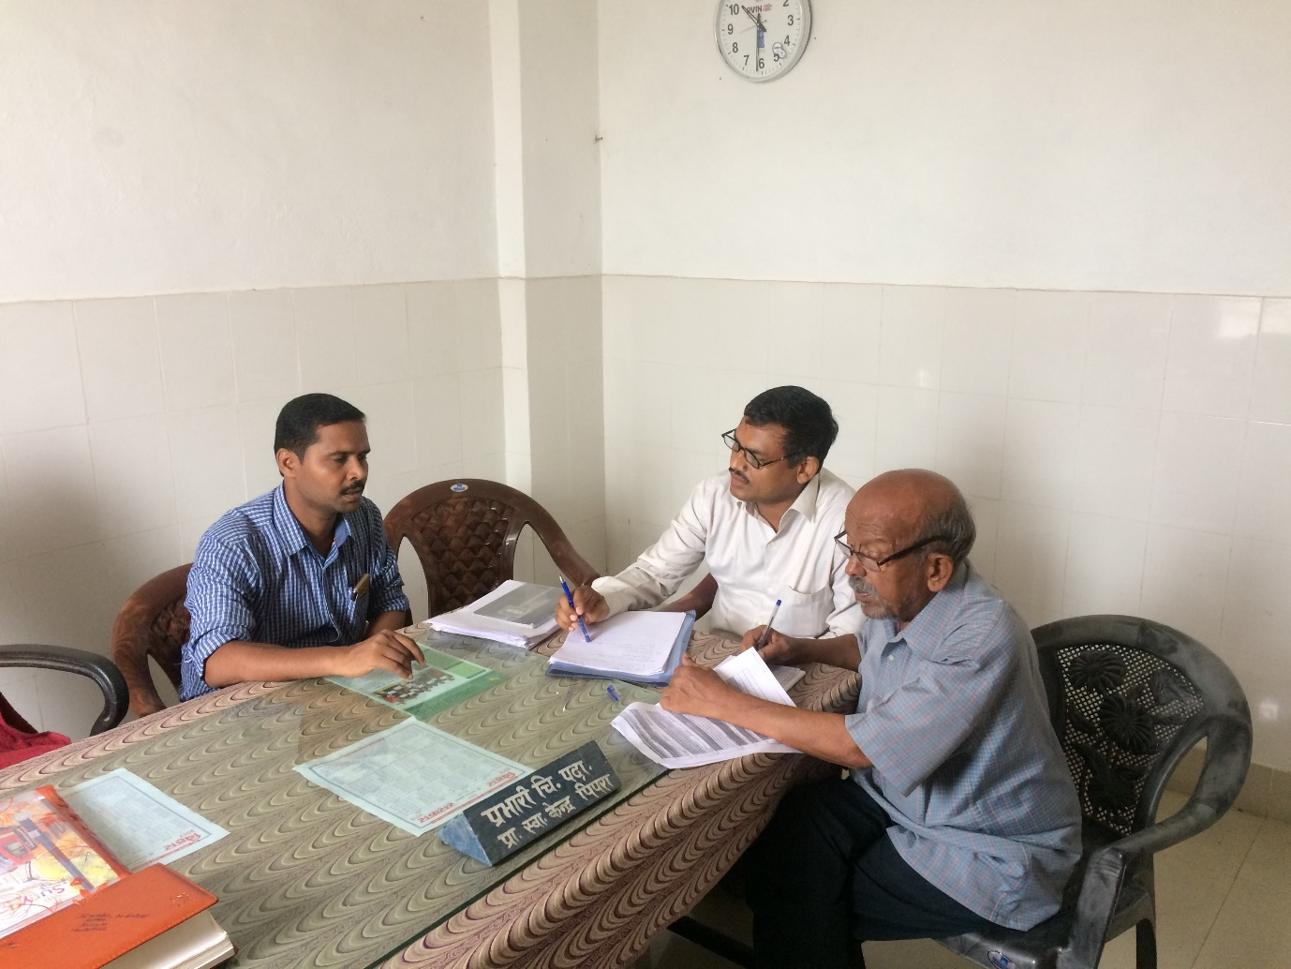
At pipariya PHC with BHM
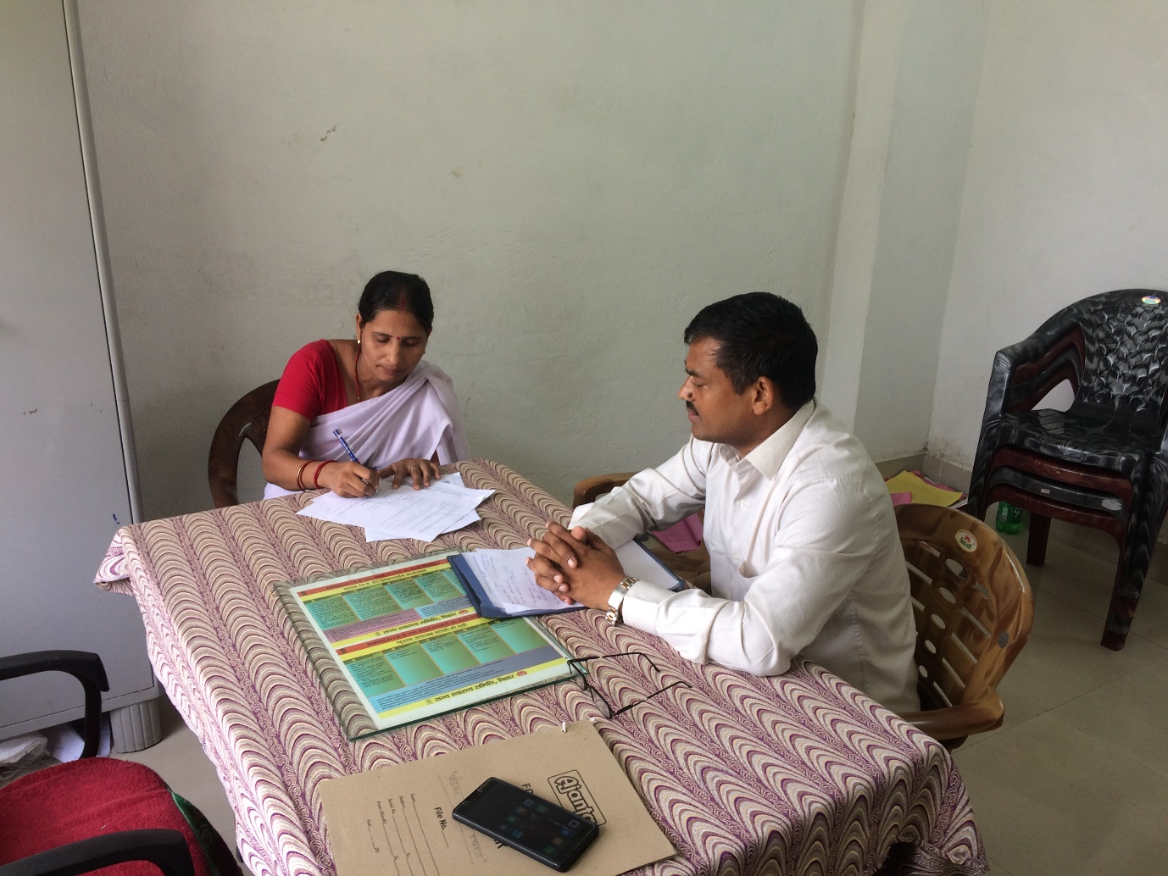
Interview of peripheral staf at Pipari block , Supaul
Worldl a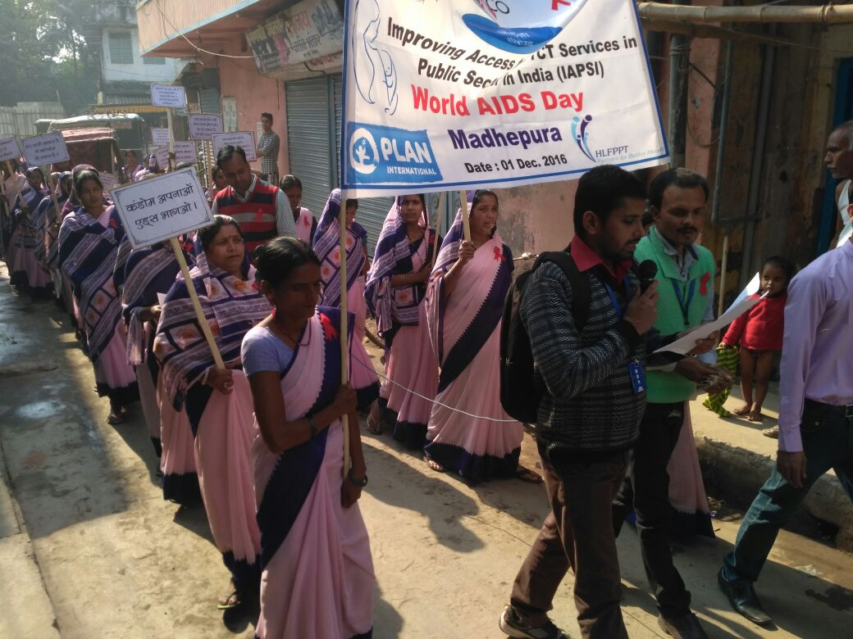
World aids day at Madehpura

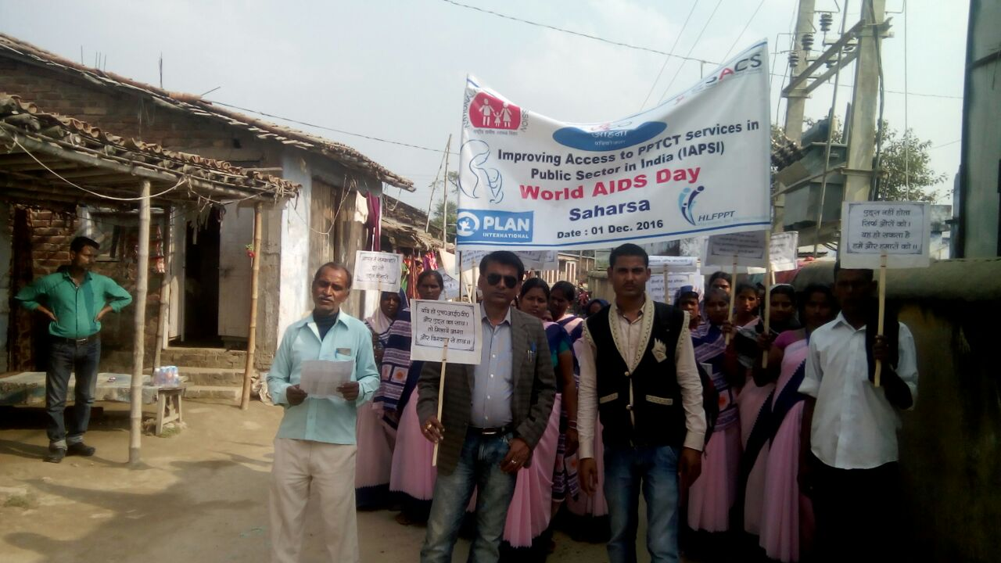
World aids dayl Sharsha
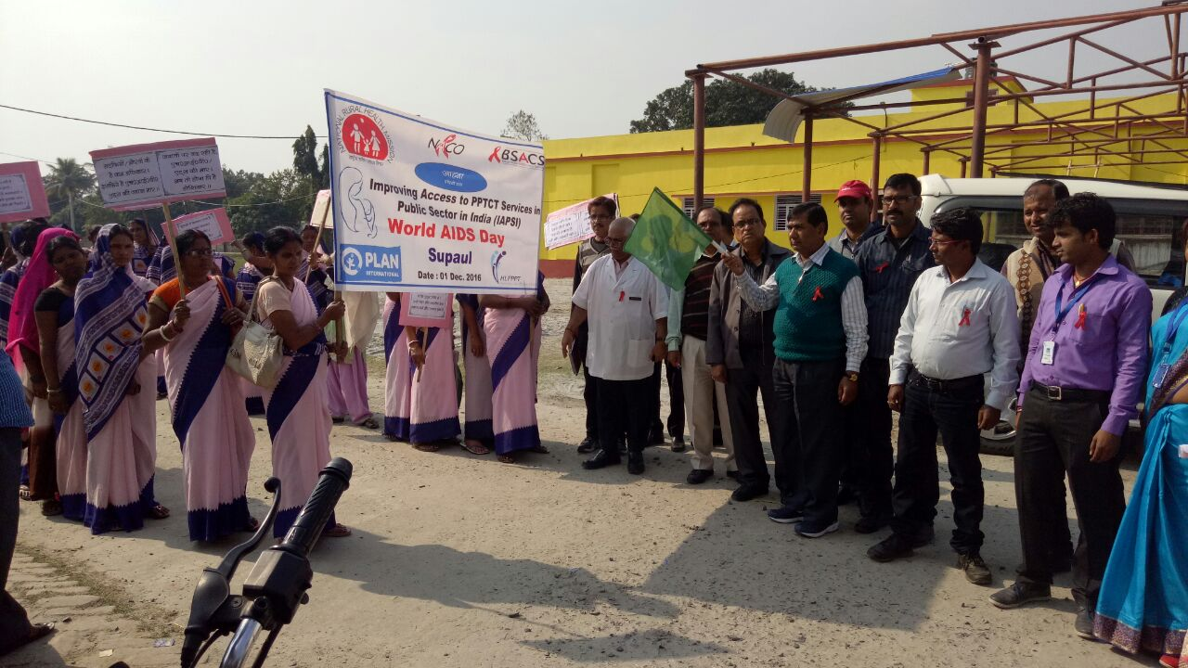
Words AIDS day Supaul
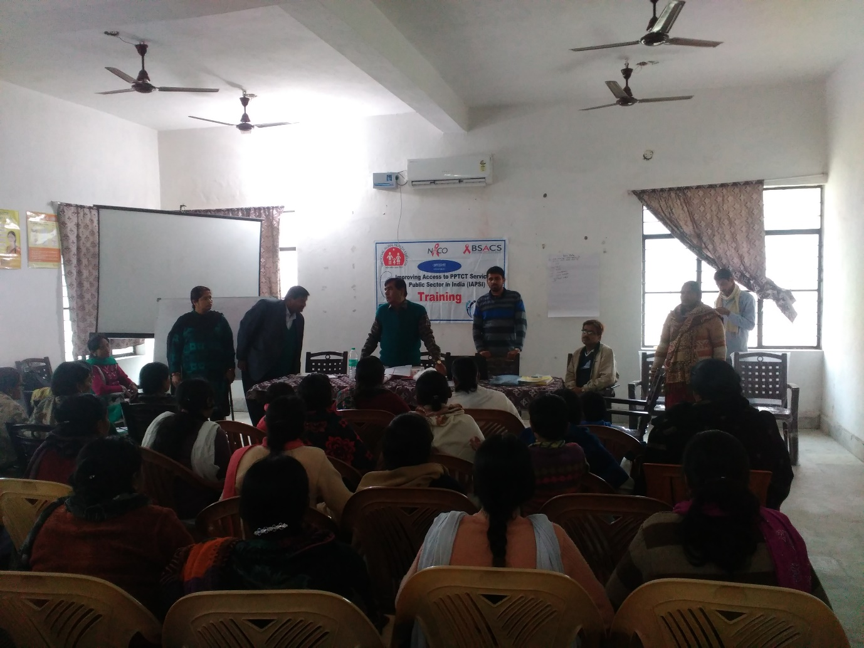
PPTCT training in Bihar
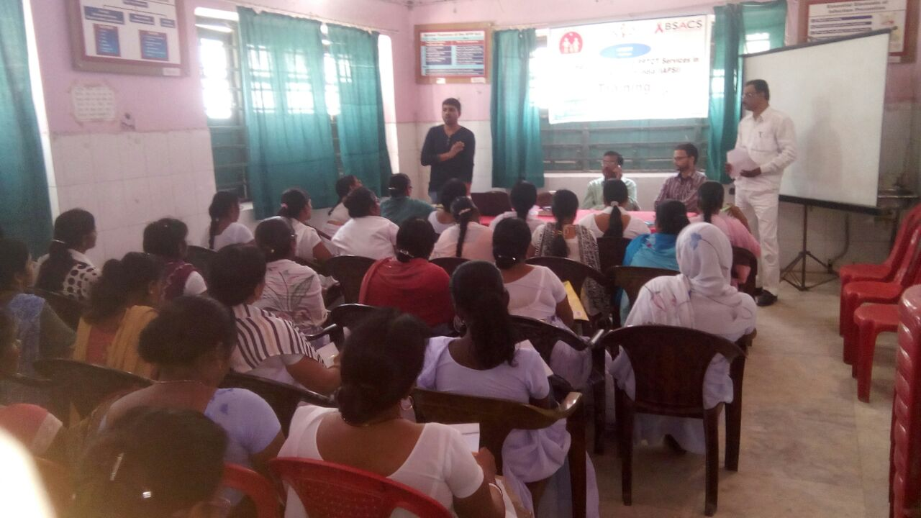
Volunteer training at Saharsha
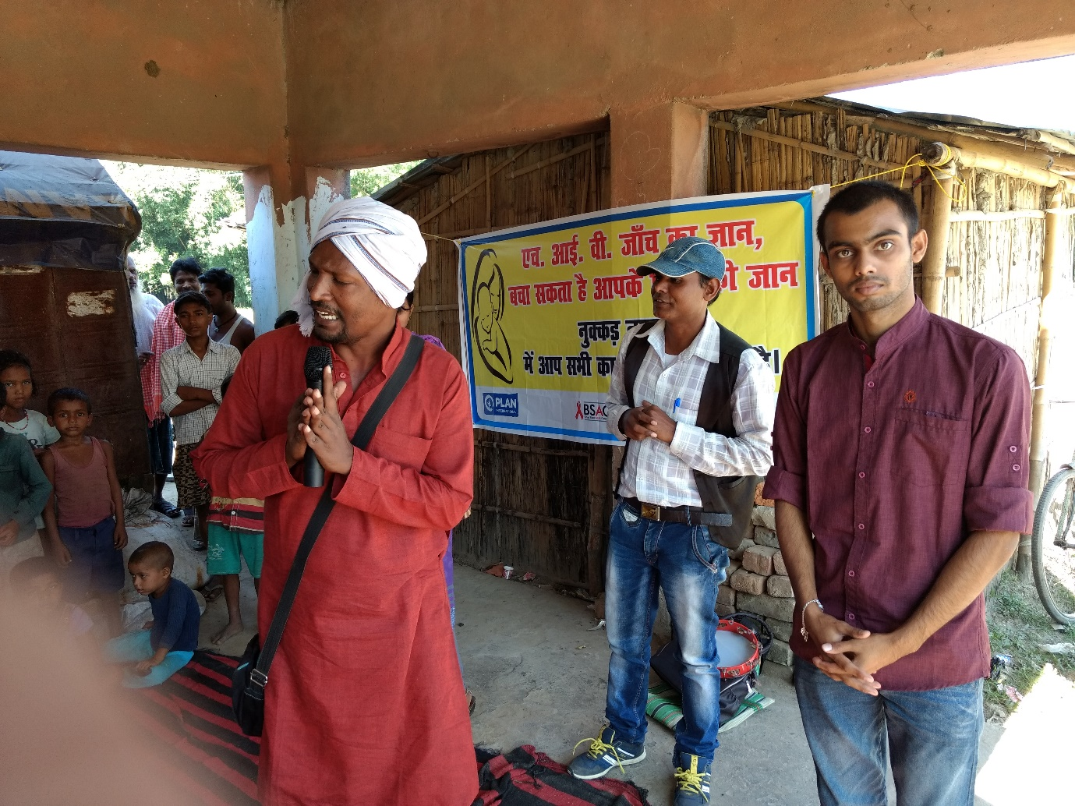
Nukkad natak in Bihar
